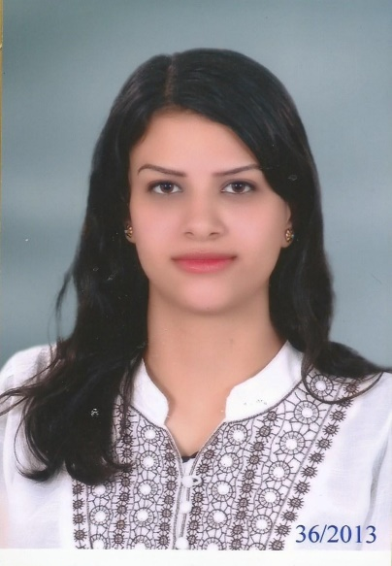
Curriculum vitae

Name: Christin
Christin.367378@2freemail.com

Introduction:
I am a hard worker person, creative writer and intrigued by redrafting sentences in both Arabic and English languages, also by translating from English to Arabic and Vice Versa.
Education:
- Bachelor of Tourism and Hotels Managements, Guidance Department, Helwan University with an average mark of 89% and excellent with honors, May/2013
- Pre-Master of Tourism Guidance with estimation B+, Helwan University, May/2014
Courses and Training:
- TOEFL course
- Training in tour guiding at the Egyptian and Coptic Museum
- English Conversation course
- ICDL course
- Communication Skills course
- Psychology course
- Human Development (Humanity) course

Work Experience:

Public Service: May 2015 / April 2016

Administrative Assistant

At Helwan University

Administration Industry: Education

Job Role: Performing administrative and clerical functions.

May 2015 – October 2015

Librarian

At the Eastern Star

Administration Industry: Charitable Organization

Job Role: Organizing books and articles in specialized place and helping people to find the needed books.

November 2015 – April 2016

Web Content Writer
At Flyin.com (based on Saudi Arabia)
Administration Industry: Travel and Tourism Company
Job Role: creating and formulating website’s content in English and in Arabic languages, writing articles, doing quality control all over the website’s content, staff training and development.
June 2015 – December 2016

Content and Social Media Manager
At Allintrip.com (based on Saudi Arabia)
Administration Industry: Travel and Tourism Company
Job Role: creating, improving and maintaining creative website’s content and its social media channels. Developing marketing strategies for the website, guiding the team members and coordinating between the departments inside and outside Egypt.
January 2017 – Currently working
Skills:
- Excellent knowledge of Microsoft Office (Word, Excel, Power Point, Access)
- Excellent knowledge of Internet navigation and in using SEO.
- Team player
- Able to solve problems
- Strong desire to learn
- Creative Thinker
Language skills
- Arabic: Mother Tongue
- English: Fluent Written and Spoken
- German: Fair
- French: Fair
Interests:
- Reading
- Playing musical instruments (Piano)
- Traveling
- Walking
Personal:
- Date of Birth: 29/12/1992
- Nationality: Egyptian
- Marital Status: Not married

