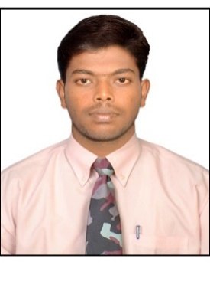

RESUME

TAMILARASAN TAMILARASAN.367431@2freemail.com

CAREER OBJECTIVE

To obtain challenging assignment in a professionally managed, organization opportunities to career development alignment with organizations growth.

Professional Experience

Organization: RASHID OBAID BUILDING MATERIAL TRADING LLC (Oct. 2016 to date)
Designation : SALES EXECUTIVE

Roles and responsibility
- Identify leads, manage prospects and acquire new business.
- Determine customer needs and propose appropriate service needs.
- Meet or exceed the new business sales goals.
- Complete scheduled and cold call prospecting activities to establish first and follow up appointments with customer decision makers.
- Prepare and deliver sales proposals/presentations and follow up with key decision makers.
- Utilize the company’s Growth Management System (GMS Board) on a daily basis, scheduling and documenting activities, and developing prospective customer profiles.
- Complete required Customer Service Agreements (unaltered), reports and other paperwork in a timely manner and in accordance with Company policy.
- Develop and maintain an awareness of market behavior and competitive trends and respond accordingly.
- Regularly meet with Sales Supervisor to review weekly sales activities, progress on goals, and status of prospective customers.
Organization: MANAPURAM GOLD LOAN PVT LTD (January 2014 – February 2015)
Designation : ACCOUNTANT Cum - CASHIER

Roles and responsibility

- Prepares asset, liability, and capital account entries by compiling and analyzing account information.
- Documents financial transactions by entering account information
- Recommends financial actions by analyzing accounting options.

Continues……2

- Summarizes current financial status by collecting information; preparing balance sheet, profit and loss statement, and other reports.
- Respond to customers’ complaints and resolve their issues
- Identify prices of goods using memory or scanner
- Debtors and Creditors Ledger Maintaining
- Enter transactions in the cash register and provide customers with the total bill
- Issue receipts and change to customers
- Petty cash handling and report to management
- Process exchanges and refunds

ACADEMIC PROFILE

COURSE/DEGREE | NAME OF THE INSTITUTION | BOARD/UNIVERSITY | YEAR OF PASSING | % OF MARKS
MBA | Valliammai Engineering College,  Chennai. | Anna University Chennai. | 2012-2014 | 62%
BBA | Jamal Mohamed College of Arts & Science, Trichy. | Bharathi Dhasan University, Trichy. | 2009-2012 | 66%

OTHER SKILLS
- General English Course With British Council Chennai and First Class

PROJECT TITLE
- Over View Of Production-Neisser India LTD Vadalur
- Financial Performance Of Ratio Analysis-Jeppiar Cements Private LTD Ariyalur

STRENGTH
- Dedicated and hard working
- Confident and smart worker
- Achieving goals through self confidence
- Good Interpersonal skills
- With the abilities to communicate effectively and clearly
Computer Proficiency
- MS Office
- Dispatching Mail
- Tally - 9

Continues…….3

DECLARATION

I hereby assure that all the information furnished above is true to the best of my knowledge

