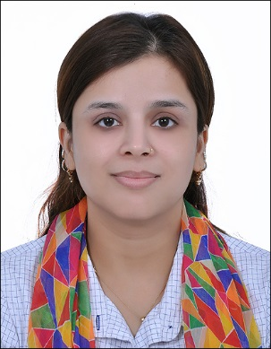
Arbina
Arbina.367514@2freemail.com
A self-motivated teacher who is determined to help pupils fully utilize the educational opportunities available to them.
• able to plan and develop appropriate teaching programs to optimize the learning process while effectively addressing individual and group needs
• proficient in the use and integration of relevant technology to support classroom instruction and learning activities
• skilled at evaluating progress through a range of assessment tools
- excellent communication skills facilitate constructive engagement with parents and colleagues decision making, critical thinking, organizing and planning, patience, tolerant, flexible to different situations
WORK EXPERIENCE
Primary Teacher
St. Mathews School - March 2015 to January 2017

Primary School Teacher
Play Way Academy - March 2012 to March 2015

Event Manager
Faconner Pvt Limited - July 2009 to July 2011
Event head

Teacher Facilitator
City Montessori School, Innovation Wing - January 2005 to August 2006

EDUCATION
- P G Diploma in TESOL /CELTA
ACT - Bangalore, Karnataka 2016 to April 2017
- Post Graduate in English Literature
Lucknow University - Lucknow, Uttar Pradesh 2002 to 2004
- Bachelor of Arts in Awadh Girls Degree College - Lucknow, Uttar Pradesh 2002
- Intermediate in English, Hindi, Physics, Chemistry, Biology
Christ Church College - Lucknow, Uttar Pradesh 1999
English, Hindi, Science, Social Studies, Computers, Maths
- St Pauls' College - Lucknow, Uttar Pradesh 1997
SKILLS
Event Management, Microsoft Word
AWARDS
Topper of the batch M. A English
ADDITIONAL INFORMATION Technology Skills:
Microsoft Office Grade Keeper

