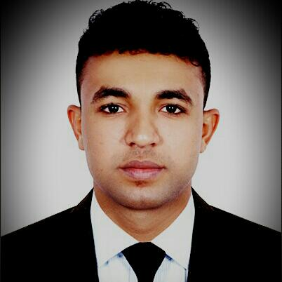

MOHAMED.367534@2freemail.com
Personal Information

Name: MOHAMED
Date of Birth: 1/1/1992
Nationality: Sudanese
Religion : Muslim
Marital status: Single

Scientific Qualifications :

Diploma in petroleum Engineering- College of Technology –Sudan University of Science & Technology
Diploma in Computer Applications & English

experiences :

*Training in Oil Refining with Khartoum Refinery Company Limited Facilities *Training at sales marketing with Tappco Lubricants company .
*Training in Drilling & Production with Sudanese Oil and Gas Corporation ( two month practical in the field of Drilling section and Production section and 4 months theory at office between Drilling section & Expogeology section & D&P geology section & Reservoir section )

*Now Working as Public Relation Officer With Atta Elshrif Business Men Services Company and I have 2 year experience at public relationship and I can clearance all the kind of procedures at :

*ministry of labor
* general directorate of residency an foreigners and affairs
* department of economic and development
* RTA
* Dubai municipality

* I can working with you on my current residence or move my residence on
your company
* working too as data entry and i have experience in typing

Skills and abilities :

*Operate computer and all programs related to it.
*Ability to Driver’s (sudanese Valid driver's license ) and now 50% from D/L issuance was completed
*Conversation Fluently in Arabic & English.
*Team spirit
*Work under pressure
*Communications skills
*Ability to convince clients
* Seriousness and dedication at work

