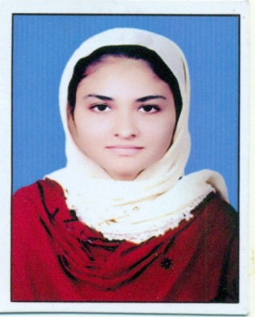
HAFIZA
HAFIZA.367551@2freemail.com
(MSc ZOOLOGY,B.Ed & HAFIZ AL QURAN)
CAREER SUMMARY – Objective

A Qualified professional teacher with more than 6 years of varied instructional experience, Creative, resourceful teacher with proven ability to enhance student’s performance and Possess a positive & effective teaching style with the willingness to work above and beyond the call of duty.

Objective is to work in an exciting and professional environment of the organization with personal development and growth possibilities and to achieve organization goals through professional ethics, sincere commitment and hard work.

Professional Experience
-  Vice Principle:- Currently I am working as a Vice principle at Al Hanan Public School Bhawalnagar. (4 year till to Date).

- Science Teacher: – I was teaching as a science teacher at Al Hanan Public School Bhawalnagar (2 years).
Vice Principle

Job Responsibilities
- Responsible for managing the assembly activities in the morning to done timely on daily basis.
- Earned high marks for quality and creativity of class room teaching, lesson plans and instructional material used in teaching diverse subject (e.g- language arts, mathematics, Biology, Physics, Chemistry, English and Islamic studies).
- Responsible for maintaining the daily register work , office work and distribution of lectures among the teachers.
- Taught general education students as well as individuals with learning challenges and special needs within mainstreamed inclusive classroom.
- To establish positive relationship/team work among the students, parents, fellow teachers and school administrators/staff for continuous improvement.
- To communicate with teachers, parents, students and external bodies foundation & government and always fulfilling the audit requirements.
- Responsible of submission admission as well as examination forms.
- Responsible for planning and scheduling of recreational activities, study tours & picnics, early result distribution ceremony and celebration of cultural events/days.
- Responsible for conduction the monthly meetings with all teachers and principle on ongoing activities & progress and also plan for achieving the goals on time.
Science Teacher

Job Responsibilities
- To manage the lecture of class room and to maintained the overall decorum of class room.
- Responsible for conduction the test and to built the competition among the students by doing the motivational activities.
- Proper planning and scheduling of lectures given effectively and also complete the syllabus on time.
- Daily, weekly and monthly monitoring of students by viewing/checking the home work, attendance marking, collecting the subjective tests and to pay the attention to individually.
- Responsible for updating the ongoing progress of whole class to Vice principle and principle on monthly basis.

Educational Credentials

- MSc ZOOLOGY from PUNJAB UNIVERSITY LAHORE in 2013.

TRAININGS & CERTIFICATIONS

- PEF training as a vice principle (to improve the management skills)
- PEF training as a science teacher (to improve the interpersonal teaching skills)

Reference will be furnished upon request

