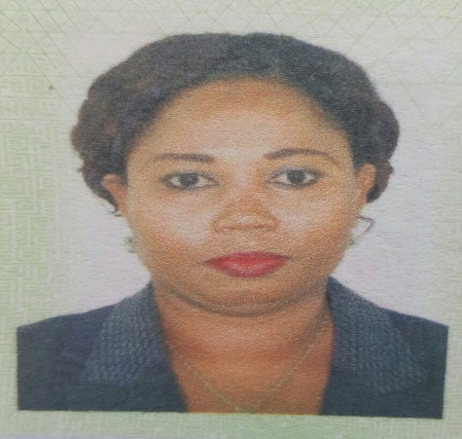
Curriculum Vitae
Jarrie
Jarrie.367571@2freemail.com

PERSONAL SUMMARY
A hard working, well-mannered and friendly Cashier/Teller/Customer Service Receptionist with positive attitude to work. Able to uphold high standards of customer service and speed whilst at the same time adhering to a company’s regulations and procedures. Experience of working in a fast-paced retail environment and having a proven track record of working under pressure.

PROFILE
Name: Jarrie
Date of Birth: 04th December 1979
Gender: Female
Marital Status: Single
Nationality: Gambian

EDUCATION
- 1993-1998 – St. Joseph’s Senior Secondary School, WASSE.

- 1998 – 1999 – Gambia Technical Training Institute, Certificate Secretarial Duties.

- 1999 Pitman Qualifications, Certificate, English for Business Communication Level 2.

- 1999 Pitman Qualifications, Certificate, Word Processing.

- 2009 O.G. Financial Services Ltd, Certificate, Fraud Agent 1.0 ENG.

- 2013 – 2016 Eco bank Virtual Banking Institute.

- 2016 – Bankers Chattered Association.

WORK EXPERIENCE
- 1999 – 2000 Gambia International Airport – IT Trainee & Receptionist.

- 2000 – 2002 Kombo Beach Hotel – Accounts Clerk proceed to Secretary to the General Manager.

- 2002 – 2003 Customs & Excise Duties – receptionist (GPA).

- 2003 – 2004 ALCO (G) Ltd. Secretary to the Managing Director.

- 2004 – 2011 O. G. Financial Services Bureau – Cashier/Supervisor MoneyGram, Western Union Transfer.

- 2012 – 2016 Eco bank (G) Teller Bulk Teller/Customer Service, ATM custodian/ Vault Custodian.

DUTIES AND RESPONSIBILITIES
- Provide customers, a personalized, friendly and efficient cashiering service.
- Taking payments from customers via cash, cheques and credit cards.
- Entering purchases into cash register then calculating the total purchase price.
- Responsible for the accurate and timely allocation of cash.
- In charge of daily cashbook management and also bank reconciliations.
- Banking a large volume of cheques and cash daily.
- Recording of monies received and paid out.
- Helping to resolve customer complaints.
- Training new cashiers.
- Sorting, counting, and wrapping currency and coins.
- Receiving savings deposits & withdrawal and verify signature.
- Help customer in all bank products and services.
- Assisted customers with opening new account.
- Handled vault, safe keys and ATM keys.
- Paying customers with POS Machine.

AREAS OF EXPERTISE
- Branch Cashiering
- Customer facing
- Computer literacy
- Doing repetitious work accurately

PERSONAL SKILLS
- Numerate
- Friendly manner
- Smart appearance
- Highly motivated
- Patient

KEY SKILLS AND COMPETENCES
- Enjoy working with figures.
- Able to follow a routine and adhering to procedures.
- Engaging in continuous learning in order to broaden knowledge and experience.
- Able to remain calm and relaxed under pressure.
- Highly focused on providing customers with a good experience.

