CURRICULUM VITAE
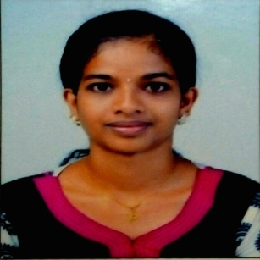

Preethu
Preethu.367580@2freemail.com

CAREER OBJECTIVE
I am seeking a competitive and challenging environment where I can serve your organization and establish a successful career for myself

EDUCATIONAL QUALIFICATION

B.E in Computer science and Engineering(Anna university Chennai, CGPA=7.83)

ACHIEVEMENTS AND EXTRACURRICULAR ACTIVITIES

Got 1st Rank in 4th and 5th semester in college Got 3rd Rank in S.S.L.C exam at school
Undergone In plant training in KELTRON, Trivandrum for 5 days Undergone In plant training in ASYST, Ernakulum for 5 days.

Attended a workshop on IMAGE PROCESSING at PSN College Of Technology and Science Attended a workshop on NS2 Network Simulator at SCAD Engineering College
PROFFESIONAL EXPERIANCE AND CERTIFICATION

COURSE

Done certification course in php(basic+advance) at IPSRSolutions ltd ,near gandhari ammankovil, thambanoor,Trivandrum,kerala,india

Worked as internship trainee in php (basic+advance) at IPSR Solutions ltd ,near gandhari ammankovil, thambanoor, Trivandrum,kerala,india

Done CCNA at Strobe Technologies adoor, pathanamthitta

COMPUTER PROFICIENCY

Microsoft Office Visual Basic
Proficiency in internet and email Adobe Photoshop

Adobe Dreamweaver

Packet tracer

AutoCAD(beginner) Tally(beginner)

OPERATING SYSTEM PROFICIENCY

Windows XP Windows 7 Windows 8 Linux

HIGHLIGHTS

Willingness to learn.

Readily accept challenges. Self-Motivated

Excellent Interpersonal skills.

Updated on current technologies. Optimistic Adaptability

PERSONAL PROFILE

DATE OF BIRTH :12 /08/1991

GENDER : FEMALE

MARITAL STATUS : MARRIED

NATIONALITY :INDIAN

VISA STATUS : RESIDENCE

LANGUAGES KNOWN : ENGLISH, MALAYALAM AND HINDI

HOBBIES

Dancing, reading, painting, crafts

DECLARATION

I hereby declare that the above mentioned information are true and correct to the best of my knowledge and belief.

