BIRJU
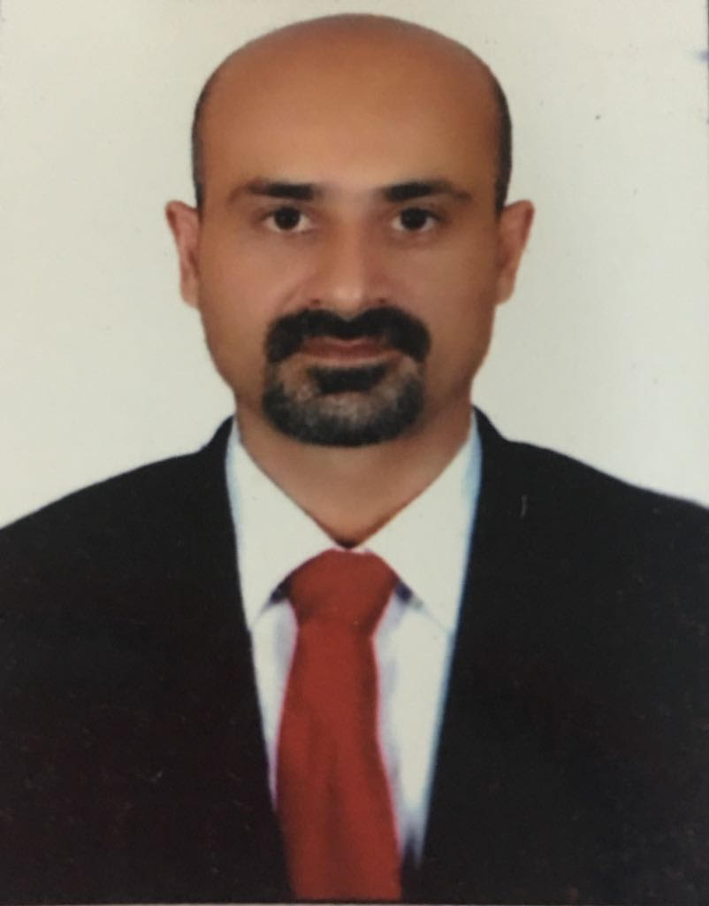

BIRJU.367603@2freemail.com

Objective: Seeking career enhancement opportunities in Global Sales & Business Development with
growth oriented organization of high repute.
Professional Précis
- Energetic Business Development professional with over 15+ years of qualitative experience ,cross-functional leadership experience in Development , Sales and Marketing of Cable Accessories , Earthing & Lightning Protection products/solutions & Customized Engineering Components in diverse geographies and can handle adversity with courage and conviction, a quality that sets apart from many.
Academia
- Post Graduate Diploma in International Business – “INDIAN INSTITUTE OF FOREIGN TRADE” – March 2013.CGPA 3.44/4.33
- E-Commerce – Asset International – Mysore-India Oct 2001.
- Bachelor, Mechanical Engineering from Karnataka University,Dharwad (KUD)-Oct 2000. Secured First Class with Distinction74%
- HSC – J.T. Pre-University College – Gadag – Karnataka-India, Apr 1996. (59%)
- SSC – Loyola High School – Gadag – Karnataka-India, Apr 1994. Secured First Class with Distinction. (84.35%)
Experience
Oct 2015 - Present: General Manager – Total Connexons Electrical LLC – Dubai.
- Responsible to handle Sales/systems/services & Profitability. Specialist in Cable Accessories, Earthing & Lightning Protection.
- Strategy development in-line with Managers and successful implementation.
- New Business Development, Create pipeline of business opportunities to make sustainable business over long term.
- Establish and maintain effective customer relationships to understand customer needs. Identifies and develops sales opportunities.
- Prepare strategies and sales plans, perform regular status reviews and propose recovery plan(s) in case of potential order shortfall.
- Prepare business plans as required to include regular visit plans to maximize sales in the identified countries.
- Assist in the setting of financial and product budgets by market and customer.
- Create added value for the customer and ensures the successful outcome of transactions, contracts and proposals.
- Establish suitable distribution channels in the identified countries.

2014- Oct 2015 – Manager-International Business, Raychem RPG – Mumbai – India.
Head-Product Management Group for portfolio of Cable Accessories, Earthing &Lightning Protection products & solutions.
- Design Analysis, Drawing Release, Commercials, Product Development, International Certification & Approvals, Technical Documents for Product Pre-qualification, Team building, Technical training to Regional Sales team & Overseas Customers.
- Product Manager for Cable accessories/ allied products viz Ex Proof Cable Glands, Industrial Cable Glands ,Cable Lugs, Cable ties, Markers Tags, Bands & Buckles, Earthing & Lightning Protection System, Connector Fittings & variety of Engineering components for Electrical & Electronics.
- Team Leader for design, development, & External Approvals like IEC Ex, ATEX, UL, CE, SASO, SONCAP, KUCAS, DNV, ABS, etc. suits product/market requirement.
- Instrumental in mapping the Electricals segment accurately for generating business inquiries for Cable accessories,Earthing & Lightning Protection accessories.
Significant Highlights:
- Project Lead & Successfully executed a Benchmark projects for developing, & getting valuable International Certifications like
- ATEX (Ex‘d’ & Ex ‘e’ Certification) for Explosion proof Cable Glands.
- IEC Ex Systems Certification.
- UL & CE for Industrial Cable Glands & Aluminium Enclosures (Junction Boxes), Stainless Steel Cable Ties.
- UL for Cable Lugs, Copper Bonded & Solid Copper Earth Rods, Metallic/Non-Metallic Cable Ties, Earthing & Lightning protection accessories.
- BS,EN,IEC Certifications for Lightning , Earthing & Grounding Components.
- Regional Certifications viz SONCAP, SASO, GOST R, RMRS, KUCAS as to assure consumers that exported products comply Country regulations.

2012-2014 – Deputy Manager-International Business, Raychem RPG – Mumbai – India.
- Evolving a complete Costing Model for Engineering Components to suit Customer’s expectation.
- Organization wide care taker to carry out impact of Currency on Business Metrics.
- Hands on experience in sourcing Engineering Commodities (Ferrous/Non Ferrous/Plastics) & Engineering components
- Managing complete Indian market for commodity sourcing & developing new suppliers & products.
- Exposure to international procurement and related rules and regulations
2010-2012 – Assistant Manager-International Business, Raychem RPG – Mumbai – India.
- Heading the RFQ department with contribution in developing / sourcing strategies both locally & internationally & share rich experience of product development.
- International commodity pricing trends. Direct interface for monitoring LME fluctuations, Alloy Surcharge & incorporating into Costing Model & ensure the price revision with Customers on the basis of global commodity rate fluctuations.
- Skilled in handling new products, developing, analyzing and evaluating various process costs in respect to current industry trend.
- Expertise in Business Development Strategies, Purchasing & Negotiation skills, Mechanical processes for product development & successful execution, Communication skills & New Ideas.
- Ensuring premium pricing for the top branded commodity products overseas.
- Streamlined the creation of MIS (monthly) for entire SBU Metrics.

2008-2010 – Sr.Executive Vendor Development, Raychem RPG – Mumbai – India.
- Responsible for identifying the supplier, negotiation & ensure that parts being Developed & Delivered as per Quality standards & Time Schedule.
- Lead and co-ordinate all NPI (New Product Introduction) activities with Engineering team, Manufacturing Team, Sourcing and Vendors.
- Lead and co-ordinate the Engineering Change Requests / Engineering Change Order incorporation in timely
manner to minimize production loss and delay in implementation.
- Support compliance to Quality System Requirements of the Organization.
- Drive Process Quality and Customer Quality Improvements.
- Co-ordinate and lead all the statutory audits for process / product.
- To impart training for operators regarding Quality functions & Quality Characteristics of products.
- To look after implementation of QMS & Quality plans on daily basis.
- To generate Quality reports & records as per record keeping procedure.
- Receipt of Original Samples/Drawings, Conversion into AutoCAD, Preparing Control Plans, Process Flow Chart, FMEA, PPAP.
- To liaise with Materials Department in Vendor Development/Appraisal activities.

Proficiency Matrix

General Manager – International Business.

Head PMG - International Business Division.

Expertise in project management including handling of multiple projects of varying scales.
Team Leader on Product Certifications

Product Development

Product Cost Estimation & Analysis

Strong Techno Commercial Skills

Pricing Manager Ability to energize, influence and build relationships at all levels within the organization.
Proven ability to execute, multi-task, and deliver on commitments.
Good communication and analytical skills.
International Exhibitions :

Participated in Worlds Power and Energy Fairs in MENA region, GCC, Europe & South East Asian countries.
- Generating new contacts, active interaction with prospective customers, better understanding of customer’s requirement (technical & commercial) that enabled us for better enquiry conversion on Customized Engineering components , Cable Accessories like Cable Ties , Bands & Buckles ,Marker Tags ,Cable Lugs , Industrial & Explosion proof Glands etc & , Earthing and Lightning Protection components.
- Successful in associating with various distributors for Cable accessories & Earthing & Lightning protection products.
- Received SIRIM & JKR Approval for Earthing & Lightning Products in Malaysia.
- Techno commercial role of promoting products & solutions to various Consultants & Contractors.

Nov’01 - Dec’03 with Cockerill Exports Pvt. Ltd. Mumbai, Engineer -Quality Assurance .
Key Accountabilities:
- Responsible for preparation of Quality Plan, Process Flow Chart , Production Part Approval Process , Failure Mode & Effective Analysis , Routine Inspection activities for Machined & Fabrication/Stamped with good Exposure to Auto Cad & Solid Works helpful for development.
- Expertise in usage of all Measurement & Inspection Instruments.
- Designing of Special Purpose Gauges as per requirement.

Workshops & Trainings Attended
- Workshop on Dimensional Metrology @ Institute for Design of Electrical & Mechanical Instruments (IDEMI), Sion, Mumbai.
- Design of Pressure Die Casting Tools , Press Tools , Plastic Injection Molding Tools , CNC Programming @ Institute for Design of Electrical & Mechanical Instruments (IDEMI), Sion, Mumbai.
- Inco terms 2010 conducted by International Chamber of Commerce-India (ICC INDIA) and Standard Chartered Bank on Nov 19, 2010 Mumbai.
- Design for Six Sigma - Green Belt 2014. Project: Software for Selection of Cable Glands.

IT Skills

Office : Proficient at MS Office

Design : A-Cad & Auto Desk Converter

ERP : MFG-Pro, Tally, Oracle Business Suite

