Jeffrey
Jeffrey.367604@2freemail.com

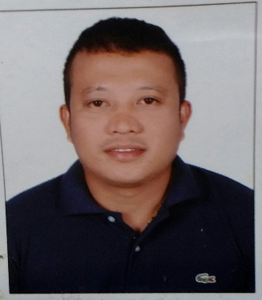

OBJECTIVE

I am seeking a competitive and challenging environment where I can utilize my skills and serve your organization and establish an enjoyable career for myself.

ADDITIONAL SKILLS

- Reading , Writing and Communication related skills
- Computer skills
- Commercial skills
- Deadline success
- Communication skills
- Mathematics skills

WORK EXPERIENCE

July 2012 –November 2016  Outlet In-Charge / Supervisor  Mangroves Lounge Coffee Shop | Eastern Mangroves Hotel and Spa by Anantara  Eastern Road, Sheikh Zayed Abu Dhabi UAE

Responsibilities:

- Compile and balance cash receipt at the end of the day shift.
- Resolve costumer complaints regarding food service.
- Inspect supplies equipment and work area to ensure efficient service, sanitation and safety procedure.
- Control inventories of food equipment, small ware and liquor and report shortage to designated personnel.
- Observe and evaluate workers and work procedure in order to ensure quality standards and service.
- Assign duties and responsibilities and work station to employee in accordance with the work.
- Estimate ingredients and supplies required to a recipe.
- Perform personal actions for staff behavior and consulting other managers as necessary.
- Analyze operational problems, such as theft and wastage, and established procedure to alleviate these problems.

October 2010-June 2012  Head Barista  Star Bucks Coffee | Shangri-La Souk /Airport Branch  Abu Dhabi UAE

Responsibilities:

- Make and serve specialty coffee and tea beverage
- Speak and interact with both new and regular guest
- Maintain a clean and sanitized work station
- Follow health and safety guidelines
- Adhere to recipes and presentations for food and beverage items
- Be punctual and able to observe regular and consistent attendance
- Contribute to a positive environment

March 2006 –November 2009  Senior Sales Consultant  Promark Strategies | Holiday Inn Hotel  Clark Field Pampanga Philippines

Responsibilities:

- Ensure the sales force is positive and are geared up for the challenge
Find out prospective costumer/clients and new target segment and penetrate sales in that area
- Teach the sales force about converting leads to sales through good communication, follow -ups and positive attitude
- Take participation in trade shows, exhibitions, networking with local associations to promote the product
- Monitoring the situation of the market, ups and down, finding out the competitors latest innovation of the product
- Complete understanding about the product and finding out how to market product to different segments

June 2003 -Feb 2006  April 2001- January 2003  Salesman/ Team leader Merchandizer | Johnny’s Supermarket Balibago Angeles City Pampanga Philippines  Pure Gold Duty free Pampanga Philippines

Responsibilities:

> Identifies business opportunities by identifying prospects and evaluating their position in
the industry; researching and analyzing sales options.
>Sells products by establishing contact and developing relationships with prospects; recommending solutions.
> Maintains relationships with clients by providing support, information, and guidance; researching and recommending new opportunities; recommending profit and service improvements.
>Identifies product improvements or new products by remaining current on industry trends, market activities, and competitors.
>Prepares reports by collecting, analyzing, and summarizing information.
>Maintains quality service by establishing and enforcing organization standards.
>Maintains professional and technical knowledge by attending educational workshops; reviewing professional publications; establishing personal networks; benchmarking state-of-the-art practices; participating in professional societies.
>Contributes to team effort by accomplishing related results as needed.

EDUCATION

Vocational: IT Basic
Filipino Institute Abu Dhabi City UAE
2016

College: Bachelor of Science in Hotel Restaurant Management
Tarlac State University Philippines
Year 1996-2000

High School: San Roque National High School
Bamban Tarlac Philippines
Year 1990-1995

