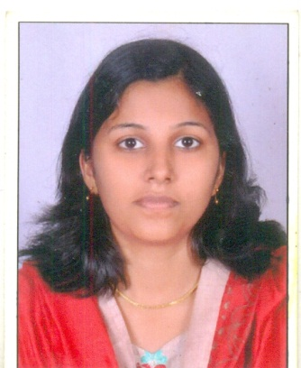
Curriculum Vita

Name: | ALPHY  ALPHY.367625@2freemail.com

Personal Details:

First Name: | Alphy
Sex : | Female
Date of Birth : | 20/06/1992
Religion : | Christian
Nationality: | Indian
Languages Known : | English, , Hindi, Malayalam
Marital Status: | Unmarried

EDUCATIONAL QUALIFICATION
Qualification | Educational Institution | Year
BSC Nursing | Sri Venkata Sai College of Nursing Mahabubnagar Andrapradesh | 2009 - 2014
Professional Registration | Delhi Nursing Council, , India
Professional Registration | Registration under the Andhra Pradesh State Nursing Council, India
Plus Two | St. Antonys Higher Secondary School, Plassnal, Kerala, INDIA | 2009
SSLC | St michaels high school Kerala, INDIA | 2007

CAREER HISTORY

Dates Employed | Organisation | Job Title
5-9-2014  to  4-9-2016 | Max super speciality Hospital  Shalimarbagh Newdelhi | Staff Nurse, ,Medical Surgical Ward and neuro ward

EXPERIENCE IN DETAIL
ECG Machine, Cardiac Monitor, Syringe Pump, Pulse Oxymeter, Glucometer, Infusion Pump, CVP Monitoring.O2 Suction Machine, AMBU Bag, Nebulizer, Central Suction Machine, All kinds of emergencies.
JOB DESCRIPTIONS IN DETAIL
• Receiving Patient in Ward.
• Implementation of nursing care.
• Evaluation of Nursing Care Implemented and making changes as required.
• History collection, Physical examination, collection of specimen, and assisting patient while undergoing necessary investigation.
• Administering oxygen nebulizer and medicines (Oral, Tropical and rectal) injections (Intradermal, Subcutaneous, Intramuscular and intravenous)
• Dressing of minor and major wounds.
• Maintaining records and reports of Patients Up-to-date.
• Patient admissions and discharges.
• Maintain patient chart and files.
• Quick assessment, Identification of Nursing problem, Devising care, setting appropriated baseline observation and implementing using intervention.
• Constant and vigilant observation recording and reporting problems that need immediate attention.
• Give patients/families on health care needs, moral support, conditions, options etc.

Declaration.

I hereby certify that the statement made by me and details above completed are true to the best of my knowledge and believe.

