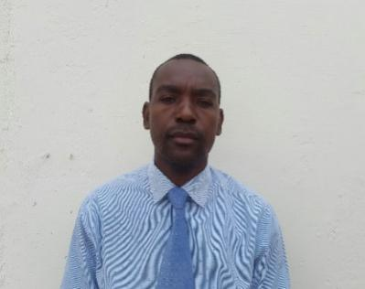
TINASHE
TINASHE.367629@2freemail.com

PERSONAL ATTRIBUTES
- I am organized and able to work under pressure with minimal supervision, producing good results.
- I am also a team player and like getting tasks done on time and to the best of my ability.
- I have good communication skills – both written and verbal. And I am able to relate to people from different backgrounds and nationalities.

QUALIFICATIONS

Bachelor of Science Honors in Information Systems - Women’s University in Africa (2012)
Micro Computer Technology - City and Guilds

EMPLOYMENT PROFILE

Computer Science and English Teacher - Glenview High School - Zimbabwe (2014 to 2017)

DUTIES
- Carry out training needs analysis;
- Define the skill sets needed to perform different roles;
- Carry out performance assessments to determine the skills gap between current and desirable learner skill levels;
- Design training programmes appropriate to the skills needed;
- Develop an appropriate mix of formal and informal development activities;
- Ensure that the learning environment and resources support learner needs;
- Design course materials and other documents such as handouts, manuals and exercises;
- Prepare the learning environment and resources, including setting up IT equipment where appropriate;
- Deliver training programmes in formal (e.g. a classroom), informal (e.g. floor-walking) or online (e.g. e-learning and webinar) settings;
- Support and coach learners using learning technologies to deliver skills;
- Evaluate the effectiveness of training programmes and learning outcomes;
- Liaise with partners (e.g. external course providers, employers, examining bodies) to fulfil the skills needs of an organisation;
- Develop peer networks to keep abreast of current thinking;
- Maintain appropriate records of learner development and resource allocation.

Systems Analyst – Econet Wireless (2013 to 2014)

DUTIES
- Defines application problem by conferring with clients; evaluating procedures and processes.
- Design and implement Web Applications as required.
- Conduct Unit, Quality Assurance and Use Acceptance Tests for all solutions provided
- Regular checks, maintenance, evaluations and upgrades on already live systems.
- Develops solution by preparing and evaluating alternative workflow solutions.
- Controls solution by establishing specifications; coordinating production with programmers.
- Validates results by testing programs.
- Ensures operation by training client personnel; providing support.
- Provides reference by writing documentation.
- Accomplishes information systems and organization mission by completing related results as needed

Call Centre Helpdesk Coordinator - Econet Wireless (2010 to 2013)
DUTIES
- Help Desk Management (Customer Support).
- Initiate second level diagnostics and additional investigations and information gathering to resolve requests/complaints or document information required for support from the Team Manager -TT
- Act as the primary point of contact for the customer support team throughout the life of a request/complaint
- Manage all allocated priority requests/complaints until resolution has been obtained and customer has confirmed restoration of service and ticket has been closed
- Properly code requests/complaints with appropriate closure codes, detailing the results of the findings and resolution on the reported issue
- Utilize available technology to efficiently respond to client request
- Uphold Econet’ s core values in the discharge of responsibilities

Call Centre Agent – Econet Wireless (2009 to 2010)

DUTIES
- Assisting customers with all Econet related queries
- Marketing all products and services
- Escalating all queries to the relevant departments so they can be resolved
- Responsible for all the Computer Hardware, Software and Peripherals Challenges.
- Carrying out Monthly Inventory sessions of the Call Centre
- Introducing new products to customers
- Outbound Telesales
- Doing courtesy call backs
- Follow up on unresolved queries
- Maintain query Turnaround times to ensure customer satisfaction

