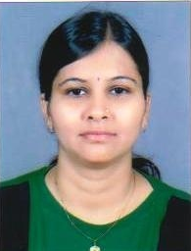
Anisha
Anisha.367646@2freemail.com
CAREER OBJECTIVE
To work with full perseverance and use my knowledge and experience towards achievement of self as well as organizational objective.
ACADEMIC QUALIFICATIONS
- I have completed S. Y. B.Com. from Gujarat University in year 2001.
SKILLS
- I have completed MS-Office from Mahila Shiskshan Sangh at Ahmedabad in year 2000 .

PROFESSIONAL EXPERIENCE
Aug 2004 to Dec 2007 : I have worked with Thermax Ltd. ( Savli, Vadodara) as QAC Assistant
Feb 2008 to May 2009: I have worked with Madhya Gujarat Vij Company Ltd. as Data Entry
Operator.( Vadodara )
June 2009 to April 2012: I have worked with Ghanshyamkrupa Jewellers as Sales Executive.
(Ahmedabad)
May 2012 to Dec. 2012: Gitanjali Group Asmi Real Diamond Jewellery, Mumbai as Area Sale
Executive for B to B (HQ – Ahmedabad , Working Area: All Gujarat)
Jan. 2013 to Mar.2016: I have worked with Shree Lalghar Swad Namkeen Enterprise
(C & A - Yellow Diamond) Sales Co-Ordinator. (Working Area : All Gujarat)
Dec. 2017 to running : I am working with Bawaji Waffers Pvt. Ltd. Mumbai, as Area Sales
Manager – Ahmedabad & North Gujarat

KEY PARAMETERS
Sincere, good grasping power, punctual

