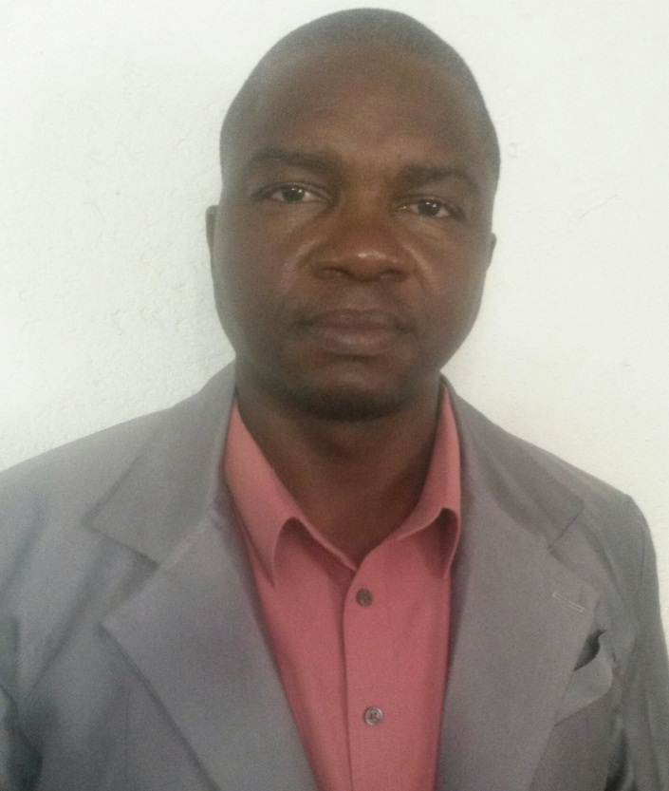
CURRICULUM VITAE
Eric
Eric.367669@2freemail.com

Profile
I hold a BSC (Hons) degree in Physics offering major courses in Physics, mathematics and chemistry. I also hold a Post Graduate Diploma in Education (PGDE). I have vast experience in teaching both in United Arab Emirates, South Africa and Ghana for the past 17 years. I have be teaching courses in Physics, Chemistry, Mathematics, Science and Physical Sciences during this period. l am capable of teaching students from grade 7 to 12. Currently I teach physics from grade 9 - 10 and Sciences in grade 8 at Wesgreen International School in Sharjah, UAE since January 2017. Some of my achievements as a teacher includes improving tremendously the final physical sciences results from 30% in 2010 when l join the teaching staff to 68% in 2011 then to 76% in 2012 to 100% in 2013 and finally to 93% in 2014 all in mdzili secondary school in South Africa. Due to this achievements I won the best educator in Mdzili Secondary school in 2011 and in 2013 and 2014 won the best physical science educator in Khulangwane Circuit . I am also a member of South Africa Council of Natural Scientific Profession (SACNASP) a body that recognize people with critical skills in the area of physical sciences in the republic.

Personal Details

Nationality/ Citizenship: Ghanaian

Date of Birth: 19th October 1973

Marital Status and Dependents: Married with 2 children

Education

Aug 2004 - July 2008 Post Graduate Diploma in Education (PGDE) - University
of Cape Coast (UCC),
Cape Coast, Ghana.

Aug 1997 - Aug 2000 BSc (Honours) in Physics - University of Cape
Coast (UCC),
Cape Coast, Ghana.

Sept 1993 - June 1995 Advanced Level Science (Physics, Chemistry
and Mathematics)- Suhum
Secondary Technical, Suhum, Ghana.

Sept 1985 - June 1990 Ordinary Level Science (Physics,
Chemistry, Mathematics, Biology etc),
Bolgatanga Secondary School, Bolgatanga, Ghana

Teaching Work History

Date Institution Responsibilities

Jan. 2017- to date Wesgreen International Teaching Physics
School, Sharjah – UAE in grade 9 and10
and Science in grade 8

Aug. 2010 – Aug. 2016 Mdzili Secondary school, Teaching Physical
Schulzendal, South Africa Sciences in grade 10 –
12, Mathematis and
Natural Sciences in
grade 8

Sept 2009 - July 2010 National Physics Coordinator Organizing workshops for
Science Education Unit Physics teachers and
Accra, Ghana. students.

Sept 2008 - Sept 2009 Canadian Independent Teaching Physics
College, Accra, Ghana and Mathematics

Sept 2000 - Sept 2008 T.I Ahmadiyya Secondary Teaching Physics
School, Kumasi, Ghana from Grade 10 to 12
and General Science
from grade 7 - 9

Interests and skill

My interest lie in motivating the youth to reach their maximum potential. I also have interest in soccer and athletics. I am also computer literate and uses computer technology to teach.

