RESUME

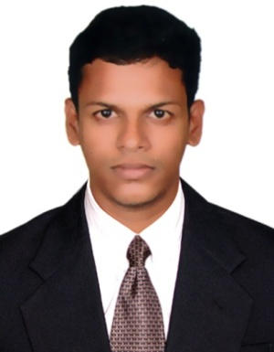

SUFIN
SUFIN.367706@2freemail.com
---------------------------------------------------------------------------

CAREER OBJECTIVE:

Seeking a position to utilize my skill and abilities in management that offers professional growth while being resourceful and flexible.

ACCADEMIC QUALIFICATION:
- PLUS TWO
Group : SCIENCE
Institution : NALANTHA GVHSS Peringotukara
Board : Kerala Board of examination
Year of passing : 2007

- SSLC
Institution : St.XAVIOR’S.H.S Chevoor
Board : Kerala Board of examination
Year of passing : 2004

ADDITIONAL QUALIFICATIONS:

- MS Office, Knowledge in computer applications

WORK EXPERIENCE:

- 1year experience as a customer service executive in AL MADINA AGENCIS & SERVICES Abu Dhabi (2014)
- Still working in G4S security services at Dubai.
- 3 year experiance in vero Eletrical.co pvt.ltd

SKILL & ABILITIES:

- Efficient communication and interpersonal skills.
- Practical computer knowledge
- Sincerity and dedication toward work
- Ability to plan and control actions to achieve results

PERSIONAL STRENGTH

- Comprehensive problem solving abilities,
- Ready to accept mistakes, willingness to learn,
- Team facilitator, Hard worker, flexible, positive thinker

DECLARATION

I hereby declare that all the statement made above is true to the best of my knowledge and belief.

