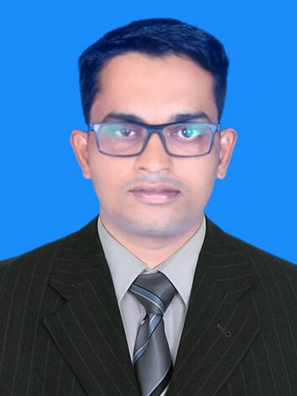
MOHIYADDEEN
MOHIYADDEEN.367711@2freemail.com

SUNIR MEETHAL SHAFI
NO. 5c, Ground Floor, Thulasi gardens
Chowdeshwari Temple Street, Martahalli
Bangalore, INDIA
Ph: +91-9742829266 email: sunirmshafi@gmail.com

Personal Summary
Seeking a Secretary position where my excellent communication skills, computer software knowledge and organizational abilities that will be helpful in contribute to the development of the organization with impressive performance.
A Graduate in Bachelor of Commerce (B.Com) from Kannur University with excellent PC skills. Seeking a challenging position in the field of Finance and Accounts whereby my academic background, interpersonal and analytical skills can be utilized and developed for the growth and success of the organization.

PROFESSIONAL EXPERIENCE
PROJECT WORKS

DESIGNATION: ACCOUNTING EXECUTIVE
COMPANY: KALLATRA CONCORD CONSTRUCTION
PERIODS: NOV 2013 TO JUN 2014
DUTIES AND RESPONSIBILITIES:
- Preparing daily and monthly reports to the Head office.
- Assisting in analyzing and maintaining financial statements and reports.
- Handling and Controlling Bills Receivable and Bills Payable.
- Reviewing and reporting out on aged receivables.
- Handling main Cash and petty cash.
- Maintaining Books of accounts.
- Preparation and verification of bank reconciliation.
- Verification of all kind of stocks.
- Preparation of Bills & Vouchers to customers.
- Responsible to preserve relationship with clients to understand their requirements
- Responsible in handling and motivating 20 employees in achieving their goals and objectives
- Responsible for administration and clerical activities of administrative departments such as answering phone calls, preparing reports and compiling files
- Responsible for gathering, analyzing and summarizing information to manager as required.
ANALYSIS OF FINANCIAL PERFORMANCE OF MAILATTY WOOD INDUSTRY

ADDITIONAL COURSE

Bachelor of Computer Application (Tally 9.0, Wings Accounting, VB, C Programming)

PERSONAL INFORMATION
NAME: MOHIYADDEEN
P.A RESIDENT OF: INDIA DATE OF BIRTH: 14th JAN 1991 GENDER: MALE MARITAL STATUS: SINGLE
LANGUAGES:
ENGLISH, MALAYALAM AND HINDI

DESIGNATION:BILLING CLERK
FIRM: SURUMAS ASSOCIATES
PERIODS:2013 FEBRUARY TO 2013 MARCH
DUTIES AND RESPONSIBILITIES:
- Handle cash transactions without any mistakes
DESIGNATION: OFFICE CLERK
COMPANY: AYSHA PANEL BOARDS MANGALORE
PERIODS: JUNE 2012 TO DECEMBER 2012
DUTIES AND RESPONSIBILITIES
- Preparing daily statements and report it to the owner
- Preparing labours wages based on piece rate system
- Analyzing quality of product and sales of the firm
- Handling and Controlling Bills Receivable and Bills Payable
- Responsible for providing administrative support to the administrative manager and managing other tasks as assigned by the manager

Key skills / competencies
- Able to work anywhere and any environment.
- Ability to manage people.
- Strong decision making and problem solving skills.
- Able to motivate and lead others in a team environment.
- Quick learner.
- An ability to build report and trust quickly with work colleagues.
- Able to prioritize tasks.
- Good convincing skill.
- Investigative

EDUCATION
- Bachelor degree in commerce from Kannur University,kerala
- Highr secoundary GHSS Angadimogar
- Till 10th standard GHSS Angadimogar,india

ACADEMIC PROFILE

2012 B.Com (Income Tax & Computer Application), Kannur University, Second Class (52%).

2008 PLUS TWO, Department of Higher Education Kerala, First class (62.33%).

2006 S.S.L.C, Kerala State Educational Board, First Class (66.53%).

SKILL SET
- Intermediate in MS OFFICE.
- Experience Intermediate in Tally erp9.0 and other similar accounting system.
- Excellent knowledge in Accounts and finance.
- Have Good communication, convincing, negotiation, influencing & interpersonal skills.
- Efficiently managing the time by the way of prioritizing and scheduling the task in advance.
- Able to solve problems with innovative ideas in order to save cost and time.
- Can handle multiple tasks effectively & very much flexible with time.

I solemnly declare that, the above statements made by me in this form are correct to the best of my knowledge and belief.
MOHIYADDEEN

