ANALYN
Analyn.367718@2freemail.com
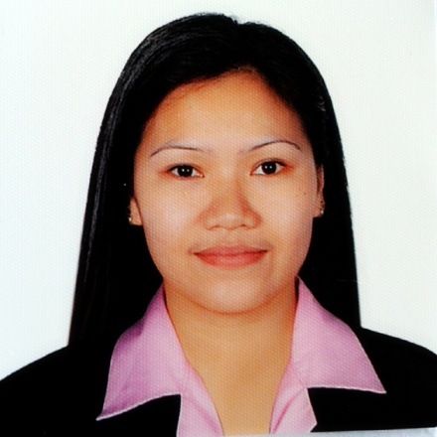

To obtain my position that is both challenging and rewarding that will allow me to enhance skills and apply my knowledge, as well as to be part of a company success.

WORK EXPERIENCE:

CASHIER/SALES
KRC International
Fresh And More Hypermarket
Abu Dhabi United Arab Emirates
April 2015-May 2017

- Arrange and package product according to the sales order.
- Assist the customer if they searching something.
- Check the product before display.
- Process credit cards and cash

MACHINE OPERATOR
Ouplus Plastic Industrial Inc.
(Hitachi Group Companies)
Philippines
May 2004-April 2015

- Operate molding machine
- Removing excess parts in the product
- Quality check the product before delivery

HOUSEKEEPING ATTENDANT
WIN Hotel Olongapo City Philippines
On the Job Training (OJT)
March 06-30,2014(150hrs.)

- Enters and prepare the room for cleaning.
- Makes bed.
- Dust the room and furniture.
- Replenishes guest room and bath supplies.
- Cleans the bathroom
- Cleans the closet.
- Vacuums and racks the carpet.

EDUCATIONAL ATTAINMENT:

Secondary:
San Guillermo National High School
San Marcelino Zambales
1999 -2000
Vocational:
Technical Education and Skills Development Authority
(TESDA)
January 2014– April 2014
House Keeping

PERSONAL INFORMATION:

Date of Birth December 18, 1983
Sex Female
Height 5’2
Weight 115 lbs
Civil Status Married
Religion Roman Catholic
Dialect Spoken Basic Arabic,English,Tagalog

I do hereby certify that the above information is true and correct to the best of my belief and knowledge.

