Experience
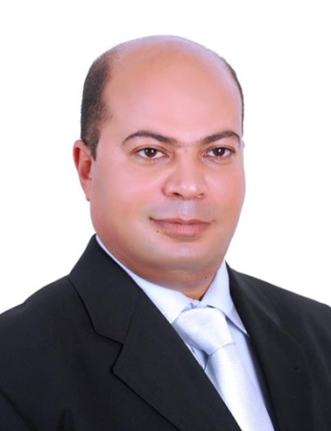

Mohamed
  - HR Administration manager
Public relation manager

Objective
More than 25 years skills & Administration Public relationships and Security knowledge & Human Resource development for achieving the company’s goals and solving problems in creative manner.
HR/Executive, Manager
PRO

personal
- Date of Birth : 11-10-1970
- Country of Nationality : Egypt
- Military Service : Completed
- Marital Status : separated
- Driving License: International & License UAE.
- Language: Arabic: Mother Tongue , English: very good in speaking & writing
- Current visa Employment

T Telephone
E Email

Alfarabi holding DIFC, dubai

dates from 2012-2016
Group HR/Administration manager

COMPANY NAME, LOCATION

dates from 6/2016 DUBAI

– present Education

SCHOOL NAME, LOCATION, DEGREE
Faculty of commerce Helwan College, Egypt, B+
HRM Higher Diploma Faculty of commerce

COMMUNICATION
Managerial skills:
- Decision maker
- Worker under pressure & stress
- Organizational behavior management and its control Economical skills
- Ability to learn & Ability to
Research
- Charismatic Presenter
- Leading team & Team Player
- Excellent Communication

LEADERSHIP
- Executive Director in a land port in a cross port Gate between Egypt and Libya
General – authority for land and dry ports from Oct 2012 till Jan 2014

GENERAL DUTIES

Core Competencies:
- Regular reviews of all policies, systems & procedures including emergency drills
- Progress any new opportunities to further improve policy & standards
- Overall responsibility for all HR/Administration related matters
- Security & Safety Management, Training, Examination & Evaluation.
- HR Management / planning / Consulting / Solutions
- Tactical & Physical planning & Training
- Advanced Self-protection Monthly Courses.
- Strategic Direction and Business Partnership Practices.
• Set HR agenda and people strategy for the Group
• Develop HR policies following regions
• Focus as key leader in strategic direction of shared services and Group Projects.
• Extend people leadership, business partnership and guidance.
• Provide advisory support.
• Support feasibility projects and business expansion.
• Develop talent & succession planning strategy.
• Design organizational structures and budgets.
• Implement compensation & benefits strategies.
• Enforce localization (achievement of quotas in line with government stipulations).
• Be an Executive Member in the Strategic leadership team

Administration Duties:

Provide the services related to government regulations and approvals and at the same time to contribute/assist in the office operations whenever required.
• submit and ensure the processing of all types of applications and paperwork to the local government bodies, including visit visas, employment or residence visas, car registrations, Trade License, labor permits, export license, economic license, foreign license, etc.
• Proactively manage the timely renewal of all Employment Visas and Labor Permits.
•Assist employees in renewing visas for their immediate dependents.
• assist all GM sponsored staff and their dependents in the medical check process.
•Send employees a notification on documentation required prior to their visa/labor card expiring.
•Manage the visa checklist as when the rules on visa/labor changes
•Assist the company and the employees with visa arrangements in Embassies immigration.
•Maintain and update the Free zone site on a regular basis by checking for expiry on CEC /gate pass/export licenses /portal accounts and ensure to manage the minimum required fund on the portal.
•To renew all company related licenses prior to their expiry date.
•Send out notifications on documentation required to renew trade licenses and complete surveys, etc. required by the government bodies at the time of license renewals.
•Submit detailed reports related to visa expenses to the finance department.
•To submit required documentation to the banks and process bank transactions as advised by the Regional Finance Manager.
•Assist in company errands when required to.

GAINED SKILLS
Managerial skills:
- Decision maker
- Worker under pressure & stress
- Organizational behavior management and its control Economical skills

Interpersonal skills:
- Ability to learn & Ability to
Research
- Charismatic Presenter
- Leading team & Team Player
- Excellent Communication

Computer skills:

- Excellent driver of Computer applications, Windows XP, Office XP & 2010
- Excel sheets professional
- Internet browsing and researching

References
Available upon request

Furnished up on Request – last update Mar. 30th, 2017

