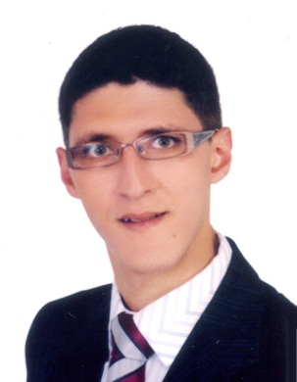

CURRICULUM VITAE

DR. Ashraf
Ashraf.367733@2freemail.com
CARRER OBJECTIVE :
- A position, in medicine Field that provides an opportunity for professional growth based on performance.
PERSONALE INFORMATION :
- Age: 30
- Gender : Male
- Nationality : Palestinian
- Material Status : single
- Place of Birth : UAE
- Date of Birth : 29/4/1986
PROFESSIONALE PROFILE :
- Capable in adapting to any new environment, new business concept, and system intrastructure.
- Ability to work under pressure, with extreme accuracy and quality.
Sharp, innovative, quick learner, ability to adapt quickly to a challenge.
- Energetic dentist with four years experience in a dental facility.
- Dental professional with vast knowledge of clinical procedures and medical and dental terminology. Periodontics, Endodontics and Cosmetic Dentistry expert

MEDICAL SKILLS:
Computer charting , Bleaching and whitening technique , Pedo and prophylaxis expertise , Endodontics (rotary) Skilled in root canals , Diagnostic aids , Infection Control , Insurance verification competency , Patient educator , Dental x-rays expertise

EDUCATIONALE BACKGROUND :
College : misr university for science & technology
Location : 6octobercity … Egypt
Completion Date : 17 – 8 – 2010
Degree Major : Bachelors of dental medicine
Description : General dentist

WORK EXPERIENCE :
- Patient care charitable society
Position : general dentist 10/4/2012 to 10/4/2013
Location : gaza …. Palestine

- Ministry of Education & Highter Education / School Health Department
Position : general dentist 2/4/2013 to 1/3/2014
Location : gaza … Palestine

- Tyba Medical Centre
Position : general dentist 1/3/2014 to 31/7/2014
Location : gaza … Palestine

- Sharjah dental & orthodontic oral & dental care
Private clinic
Position : general dentist 15/5/2013 until 1/6/2015
Locaton : gaza … Palestine

- AL Qusais Medical Center
Private clinic 20/10/2016 until 14/1/2017
Position : general dentist
Location : UAE … Dubai

practice and licensing certificate :
• license to practice dentistry in Palestine 5/4/2012
Registration
• DHA licence 20/10/2016

Language Proficiency :
- Arabic (mother lang.)
- English ( excellent )
CONFERRENCE :
Attindance of difference local & international confrrence from the day of my graduate

COMPUTER SKILLS :
- Microsoft Office Suite (MS Word, MS Excel, MS Power Point), Accounting Programs, Internet.

