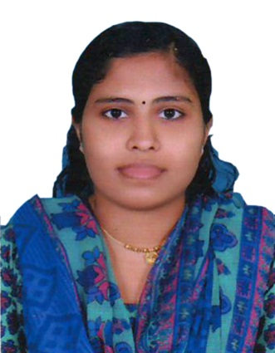
Pravitha
Pravitha.367736@2freemail.com

OBJECTIVE
Dedicated, hard working and competent healthcare professional with 2 year and 8 months experience providing superior care to multicultural patient populations. Demonstrated ability to ensure provision of quality patient care in accordance with facility’s policies and procedures. Committed to maximize patient satisfaction through the delivery of passionate care in a specialized care environment.

CERTIFICATIONS
- Dubai Health Authority Eligibility Letter
- Kerala Nurses And Midwives Council Registration (Reg.No:62452)
- ACLS
- BLS

SPECIAL SKILLS
• Making appropriate adjustments and modifications to the treatment plan
• Developing and maintaining effective relationships with patients and families
• Delivering safe and effective patient care
• Conducting ongoing education for patients

PROFESSIONAL EXPERIENCE
Staff Nurse Haemodialysis unit – Aster Mims Hospital, Calicut| Oct2015-Aug2016
- Arrange dialysis equipment according to patients’ requirements
- Oversee dialysis procedure from the beginning to fruition
- Ensured compliance with standards of care outlined in hospital policies and departmental policies
- Educated patients regarding their conditions and possible treatment options.
- Assisted physicians in all aspects of patient care, including medication administration
• Identify problems or irregularities in the dialysis procedure
• Provide post care and pre care to dialysis patients
• Prepare dialysate and assemble extracorporeal circuits
• Document patient progress and manage reports
Staff nurse Haemodialysis Unit – Red Crescent Hospital, Calicut | Feb 2014– Sep 2015
- Provided direct patient care in terms of personal and medical care
- Assessed patient health and record information
- Administered medication and IVs as instructed Executed plans of care to assess effectiveness
Of hemodialysis treatment Explains to patient all the phases of treatment per physician's orders.
- Maintain effective channel of communication.
- Perform analysis of patient's data; assess and monitor status of vascular access, review laboratory results, assess patient's condition throughout the procedure and report any relevant changes or abnormalities to physician
- Ensured patients’ nutritional needs

ACADEMIC QUALIFICATION
- BSc Nursing, College Of Nursing, Kannur Medical College , Kannur, India
- PLUS TWO From Kerala Board Of Public Examination, India
- SSLC from Kerala Board Of Public Examination, India

REFERENCES: Available on request

