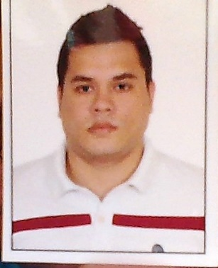

CURRICULUM VITAE
OBJECTIVE :
To work hard in a healthy based environment and to the best of my abilities and leadership qualities with my main focus on the benefit and profit of the organization.
PERSONAL DETAILS:
NAME : JERETH

JERETH.367747@2freemail.com
EDUCATION QUALIFICATION :
The Frank Anthony Public School Kolkata 2011. ( ICSE – 75%)

The Frank Anthony Public School Kolkata 2013. ( ISC – 65%)

Sikkim Manipal University , ( Bachelors in Business Administration, BBA – awaiting mark sheets and certificates ) (correspondence 2014 -2017)

EXPERIENCE :
WORKED AT XPERTECH SOLUTIONS (2013 - 2015)
WORKED AT JOHN KEELS BPO NEW DELH 2015.
WORKED FOR TELEMNDS INFOTECH KOLKATA(2015-2016)
FREELANCED IN ORGANISING AMATUER FOOTBALL EVENTS (STILL ORGANISE FROM TIME TO TIME)
WORKED FOR RETAIL LUXURY BRAND “ FURLA “ QUEST MALL KOLKATA 2016.
VPLAY SPORTS CLUB KOLKATA (event organizer / assistant trainer football) (presently working )

ACHIEVEMENTS :
. VICE HOUSE CAPTAIN AND PREFECT IN SCHOOL
. TRAINED UNDER 2ND DIV PREMIER LEAGUE TEAM SHEFFIELD
UNITED FOOTBALL CLUB
. SMALL SCREEN ROLE DONE IN TOLLYWOOD MOVIE ‘EGARO’
. PARTICIPATED IN INTER SCHOOL STATE BASKETBALL
TOURNAMENT
MERITS :
. BASIC KNOWLEDGE IN COMPUTERS
. GOOD COMMUNICATION SKILLS
. LEADERSHIP QUALITIES
. GOOD PROBLEM SOLVING SKILLS

