CURRICULUM VITAE  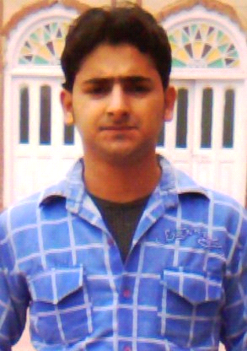  SALIM  Email: Salim.367792@2freemail.com  Personal Profile:  Date of Birth : 8th  may.1992  Nationality : Indian  Sex : Male  Marital Status: Single  Languages : English,  Known Kashmiri  Hindi |  | CARRER OBJECTIVE:  Seeking a challenging job in esteemed organization that will channel my skills and utilize my  strong analytical & problem solving abilities where I can learn and gain knowledge and  serve the organization .  QUALIFICATION  Professional Qualification:  B.Tech (Electronics & Communication )  From Aligarh college of Engineering & Technology Aligarh in year 2014  Utter Pradesh Technical University Luckhnow (U.P) With 65% .  Academic Qualification :  - Passed 10+2 from J&K Board in 2009 .  Passed 10th from J&K Board in 2007  TRAINING EXPERIENCE  Website developer in Shristi Infrastructure Development Corporation Ltd.  DURATION: 6 MONTHS  PROJECT  PROJECT : TRAIN ANTI-COLLISION AND UNMANNED BARRIER ,  DESCRIPTION : PREVENT THE COLLISION OF TWO TRAINS  USING RF AT THE SAME TRACK BY  PRESSURE SENSOR  ROLE : Designing and implementation  TECHNICAL PROFICIENCY  Operating system : windows, linux  Languages : Basics of C  Operating systems : Windows  Others : Good knowledge about Electronics  Components & operating system or Computer
Reference: | HOBBIES & INTERSTS  - Net surfing.  - Volley ball  - Listening Music.  DECLARATION  I confirm that the information provided by me is trueto the best of my knowledge and belief.  Place :  Date :  SALIM YOUSUF TANTRY

