ASRAA
Finance Graduate

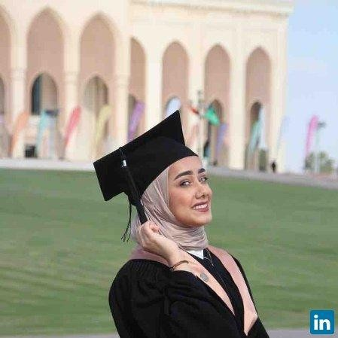SUMMARY

 Sharjah University Road, Sharjah, United Arab Emirates

 asraa.367807@2freemail.com
Seeking a job in reputable company or bank where I can have practical experience to build on my didactic education in the field of Finance & Banking. I am fast learner, dedicated individual with leadership skills that will enable me to excel in my future career.

EDUCATION
2017 Bachelor Of Science in finance and banking University Of Sharjah

2015 Course in Auditing of Islamic Banking Islamic Center for studies and researches
gain a knowledge regarding different accounting transactions of islamic banks

2010 - 2011 The 25th Secondary School
Dammam, Saudi Arabia

CERTIFICATIONS
2016 - 2017 Training program in Emirates Islamic bank Halwan branch, Sharjah
I have been completed a training program in Emirates Islamic Bank seccessfully according to the rotation schedule in customer service and teller service. During my training I was helpful and hardworking.

2015 - 2016 Chair of the Finance Club
The department of finance and economics, Sharjah University
- lead all meetings.
- Give guidance, assistance, and praise

2015 - 2016 Secretary of student Council
university of sharjah
- Keep an accurate account of attendance at every meeting
- Help maintain student council files
- Maintain contact information for people who work with the council

2014 - 2015 member of rehab club
UNIVERSITY OF SHARJAH
organizing an events that encourage students to join a wonderful world of literature.

2014 - 2015 volunteer of the finance club
THE DEPARTMENT OF FINANCE AND ECONOMICS, SHARJAH UNIVERSITY
help the members of finance club in different events.

2014 - 2015 attendance of Nonverbal communication and Body Language in Relevance to Job Interviews
THE DEPARTMENT OF FINANCE AND ECONOMICS, SHARJAH UNIVERSITY
such workshop gave me a knowlege regarding how to use my body language in job interviews.

2014 - 2015 Organizer of the Emirates Club
University Of Sharjah, Sharjah
help the members of Emirates club in different events.

2014 - 2015 Attended the 1st Sharjah International Conference on Islamic Finance
University Of Sharjah, Sharjah & Islamic Center for studies and researches

2013 - 2014 Member of the Business Students Association business ADMINISTRATION college, Sharjah university plan and organize for different events

AWARDS
2014 awarded for participating and recognition of research presentation entitled “Capital Structure and firm’s performance in the UOS Business Forum
business administration college

ACADEMIC RESEARCH
2017 Factors that influence Islamic finance development within the UAE

2016 The career potential of Certified Financial planner

The effect of capital structure on firm’s performance 2016

2016 Factors derives the real estate prices

2015 - 2016 Student’s acceptance of Electronic service

SKILLS
Fluent in Arabic and English.
Management skills.
ability to communicate with others.
knowledge in computer. Microsoft Office, and SPSS.

