RESUME
Nikitha.367990@2freemail.com
Nikitha
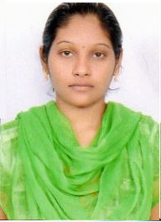

CAREER OBJECTIVE:
To pursue a challenging career in leading and progressive research organization offering opportunities for utilizing my skills towards the growth of the organization.

Educational Background:

Year | Degree | Board/Institute | Percentage/CGPA
2012-2016 | B.Tech  (Mechanical Engineering) | AVR & SVR College Of Engg., & Tech., Nandyal | 69%
2010-2012 | SBIE | Nalanda junior College , Nandyal | 63%
2009-2010 | Board of Secondary Education | Rotary E.M School, Nandyal | 75%

TECHNICAL SKILL:
- Programming language : C Language
- Packages Known : MS-Office.
- Operating Systems : Windows,Windows XP
- Technical Language : AUTO-CAD.
: 2D Drafting Package
: 3D Drafting package
PERSONAL SKILLS:
- Smart working nature through understanding of subject.
- I have good imaginative thinking skills.
- Flexible.
- Motivating others.
- Leadership skills.

EXTRA CURRICULAR ACTIVITIES:

- Actively participated in workshops.
- Event organizer in college technical and non-technical events.

DECLARATION:
I do here by confirm that the information given above is true to the best of my knowledge.

