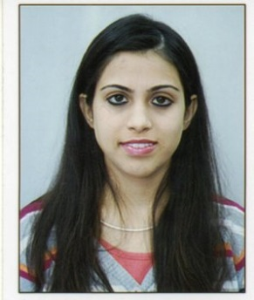

VRATIKA

VRATIKA.368000@2freemail.com

Career Objective

A position as an Event Manager with a dynamic firm that will allow me to utilize my unique abilities and advance my career because nobody is experienced they become experienced by learning from basic level. To synergies my acquired knowledge, skills and abilities so to excel in the corporate management, seeking a challenging career in the Retail Industry.

Work Experience

More than 3 years of an experience in Retail Sales and Event Management industry.

Country Star Building Materials LLC December 2013 to December 2015

Job Title: Sales and Services

Description: This Company is into sales and services of Construction and building material trading.

The main role is acquisition of the new customers and involved in the customer sales and after sales services to strengthen relations for selling of company’s products.

As well as managing the relationship with the existing customers and provide them the batter after sales services for the future business and references.

Mangal Mantra Event Management Company August 2012 to July 2013

Job Title: Co-ordinator

Description: This Company is into event management like wedding events, talents shows, corporate events and small and big functions organizers.

Hotel Star & Restaurant June 2016 to March 2017

Job Title: Front Office Manager
Description: The Hotel is located in Ajmer near Dargah Sharif which is one of the international pilgrimage centres in the world.
Academic Credentials

I have done my M.A (Master of Arts) specialization with the Sociology subject with 2nd Class Maharshi Dayanand Saraswati University in 2014.

I have done my B.A (Bachelor of Arts) with 2nd Class from Sophia Girls College, Ajmer from Maharshi Dayanand Saraswati University in 2012.

I have done my 10th (S.S.C.) and 12th (H.S.C) with first class in both exams from Central Board Secondary Education, CBSE in 2007 and 2009.

ADDITIONAL QUALIFICATION

I Have done my Diploma in Event Management from NAEMD (National Academy of Event Management & Development), Jaipur, India in July 2012 to June 2013.
I have done my Diploma in Fashion Designing from ED EXCEL Dubai UAE from September 2013 to December 2014.

INTRESTS & HOBBIES

- Travelling
- Dancing
- Interact with people
SKILLS AND STRENGTHS

- Hardworking, Good Communication Skills, Self-motivated and strong enthusiasm to accept challenges & work with commitments.
- Ability to learn new concepts and ideas and apply them to any practical situations.
- Ability to work well in any kind of pressure, working methodically and prioritizing tasks in a calm and professional manner.

ACHIEVEMENTS

- Participated in Wedding Events with MANGALAM MANTRA in Kota in Sept. 2012 and April 2013
- Internship with BALLERINA SPARSH exhibition in Sept. 2012
- Trainings in Dance India Dance and Sare Ga Ma Pa Auditions
- Training in Corporate Events of Mahindra and Mahindra
Personal Information

Date of Birth | : | 14-08-1990
Languages known | : | English, Hindi, Sindhi
Marital status | : | Single
Nationality | : | Indian

