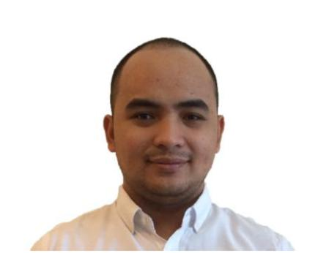
Mark

Mark.368010@2freemail.com

Summary

Organized and dependable who excels at processing high volumes of error-free transactions and meeting goals. Detail-oriented with 2 years of work experience. Focused on maintaining high levels of accuracy and efficiency, as well as achieving company goals and objectives.

 |  | Highlights
• Keen eye for detail |  | • | Highly motivated
• | Dedicated team player | • | Adaptable
• | Goal oriented | • | Time oriented
• | Excellent work ethic | • | Fast learner
- MS Office proficient

Experience

Treasury Assistant – March 2016 to April 2017

Meridien Business Leader, Inc. (The SM Store) – Olongapo City, Philippines

- Day to day Audit of Coins.

- Receives money from Cashier’s final turnover.

- Receives money pick-up from Cashier’s counter and Bills Payment counter.

- Ensures that Bills Payment’s actual turnovers are balance versus their final turnover report.

- Day to day banking transaction

- Currency Exchange.

- Processing remittance international and local.

Sales Executive – August 2014 to February 2015

Subic Bay Yacht Club, Inc. – Subic Bay Freeport Zone, Philippines

- Handling corporate and social events.

- Conducting sales call.

- Making revenue and expense report of every event.

- Updating Data Base.

- Email and Text Blasting.

Membership Assistant – June 2014 to July 2014

Subic Bay Yacht Club, Inc. – Subic Bay Freeport Zone, Philippines

- Assists in updating membership database.

- Assists members with their needs during their visit to the club and man the membership desk whenever needed.

- Deals with member complaints / requests who visited the club.

- Answer phone calls inquiries of members.

- Coordinate with other departments to verify member complaints regarding their charges.

Treasury Assistant – January 2014 to June 2014

Subic Bay Yacht Club, Inc. – Subic Bay Freeport Zone, Philippines

- Preparation of the weekly budget.

- Preparation of Check Disbursement Report.

- Preparation of checks, routing for signatures, and providing summaries and duplicate copy of all prepared checks.

- Preparation of checks for the salary of contractual and casual employees.

- Preparation of checks and necessary forms for employee related payments such as withholding tax, PAG-IBIG and Phil Health payments and payment remittances to affiliated banks.

- Daily checking of Cash Collection and Cash Disbursement Report.

Education

- BSBA – Major in Human Resource Development Management, Graduated – March 2014

Columban College, Inc. – OLONGAPO CITY

I declare under the penalties of perjury that this resume has been accomplished in good faith, verified by me and to the best of my knowledge and beliefs a true, correct and complete statement.

