SANDESH

SANDESH.368030@2freemail.com

Career Objective:
- To associate with an organization where there is an ample scope for organizational as well as individual growth
- Seeking a position to utilize my skills and abilities that offers professional growth while being resourceful, innovative and flexible.
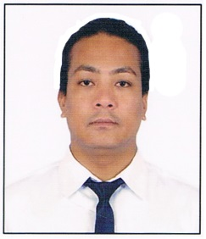

EDUCATION
TRIHUWAN UNIVERSITY
Ratna Rajya Laxmi Campus
Bachelor’s Degree 2009
Humanities & Social Sciences
2nd Division
H. S. E. B.
Bagiswori Higher Secondary School
+ 2 2006
Humanities
2nd Division
H. M. G.
Genuine Secondary School
SLC 2004
1st Division

PROFESSIONAL EXPERIENCE
National Mobile Center
Sinamangal-9, Kathmandu
Sales and Customer Care Officer 2014-2017
Costumer Handling, Marketing and Sales management
National Mobile Center
Sinamangal-9, Kathmandu
Sales Assistant 2013-2014
Showroom Sales person
Almarai Company
Dammam Depot, Saudi Arabia
Salesman Assistant 2011-2013
Focuses sales, Submits orders by referring to price lists and Monitors competition by gathering current market place information

LANGUAGES

English: Listening, Speaking, Writing, Reading
Nepali: Listening, Speaking, Writing, Reading
Newari: Listening, Speaking
Hindi: Listening, Speaking, Reading

SKILLS
Computer Literate – Microsoft Office and other applications
Rapport Building and Customer dealing

