Karthika Karthika.368031@2freemail.com 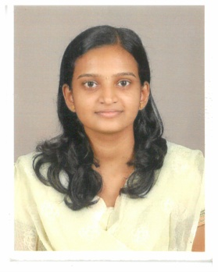

OBJECTIVE

To build a professional carrier with the ethical builds of the company in working with professionals to learn the skills and can adapt to every situation at any time.

ACADEMIC QUALIFICATION

ACADEMIC QUALIFICATION | INSTITUTE | UNIVERSITY/BOARD | Year of Passing | CGPA
BE ELECTRICAL AND ELECTRONICS | VIVEKANANDHA COLLEGE OF TECHNOLOGY FOR WOMEN | ANNA UNIVERSITY CHENNAI | 2014 | 7.5
12th | GOVT.GANAPATH.GIRLS HIGHER SECONDARY SCHOOL | KERALA STATE BOARD | 2010 | 8.3
10th | GOVT.GANAPATH.GIRLS HIGHER SECONDARY SCHOOL | KERALA STATE BOARD | 2008 | 9.5

PROJECT PROFILE
TITLE - Identification of fruits and vegetables using color processing.
SOFTWARE EXPOSURE
AutoCAD, Electrical CAD
Familiar with all PC based Applications

AREA OF INTEREST
- Power System
- Electrical Machines
- Digital Image Processing
WORKSHOP AND INPLANT TRAINING
- Attended workshop on PCB Designing Techniques.
- Attended workshop on Robotics.
- Completed a short term course on Real time Embedded system & application.
- Attended four days IN Plant Training in B.S.N.L. Dharmapuri.
- Participated in the DRDO sponsored National level seminar on recent advances in Power Electronics Technology for Electrical Machine Drives.
WORK EXPERIENCE
- Employer : National Engineering Company (Leading ‘A’ Grade Electrical Contractor in Kozhikode) (From July 2014 to March 2017)
ROLES AND RESPONSIBILITIES
- Estimate value of Commercial/Residential/Industrial projects being tendered as a part of business development through scrutiny of Tender documents.
- Evaluating Tender drawings, specifications, schedules and bill of quantities.
- Floating enquiries to Suppliers/Manufactures, comparison studies based on Supplier quotations.
- Execution of project and materializing the Purchase orders, Organize and evaluates supplier submittals and Quotations.
STRENGTH
- Responsibility
- Adaptability
HOBBIES
- Reading books
- Listening music
- Browsing internet

DECLARATION:

I hereby declare that the above written particulars are true and correct to the best of my knowledge and belief. I also commit that; I will do my duties to the best of my ability.

