Curriculum Vitae
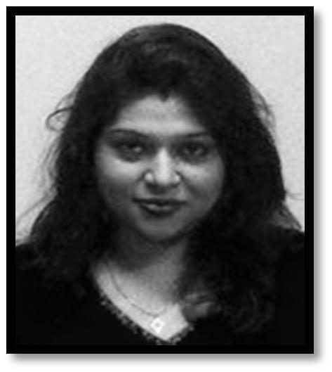

SONIKA

SONIKA.368067@2freemail.com

Analytically inclined, extremely hard-working finance executive with high integrity, and passion for finance management and banking. Quick learner with believing in perseverance and focus on value

centricity.

Areas of Excellence Include:

 | Income Tax management |  | Inventory management
 | Research and analysis |  | Budgeting & Cost Control
 | Internet Savvy | Proficiency in MS Office

Known for problem solving ability to quickly analyse key driving points and develop strategy to envision and create successful outcomes in complex situations.

Have rich experience in finance, accounts handling and research. Utilize primary and secondary research data to identify trends and come up with meaningful outcomes.

Excellency in computer and software usage with variety of vocational trainings and experiences, which includes on-job training by the government department; having attained academic trainings in the past.

Professional Experience:

Bauddh Vihar Shanti Upvan (Lucknow Development Authority) in Lucknow, India: Working as Assistant Accountant.

  - A first-hand experience in finance management and accountings; having gained an exposure to the work of the governmental organisation working towards the state tourism under the LDA administration.
  - Contributing into the work and experiencing the management of budget-based system in this organisation.

  - Being an important part of the finance management team, contributed in achieving the organisational goals by establishing internal network and keeping good practices in line.

  - Accurate reporting of the weekly revenue for the management.

  - Assist with closing month end, preparing financial statements and reports, maintaining weekly cash-flow of existing project in tourism. It further includes: bookkeeping and other administration work, recording of cash activities on a daily basis, processing employee’s salaries and expenses, approving payment transactions, answering finance queries.

  - Assisting the Head of Finance in day-to-day activities.

  - In these years, developed a great deal of customer value propositions for all appropriate business opportunities.

June 2011 – Present (6 years)

1 | P a g e

Education Details:

- Sikkim Manipal University, Gangtok (India)

Master of Business Administration (MBA) in Finance Management
Classification: Awarded with Merit
September 2013 – July 2015

- Avadh Girls Postgraduate Degree College, University of Lucknow, Lucknow (India) Bachelor’s Degree: Bachelor of Commerce (B.Com.)

July 2006 – July 2009

- St. Joseph Senior Secondary School, Kanpur (India): Central Board of Secondary Education ‘Intermediate’ April, 05’ – March 2006

- Lucknow Public Collegiate, Lucknow (India): Indian Certificate of Secondary Education ‘High School’
April, 03’ – March 2004

Professional Qualifications and Achievements:

A governmental vocational training and certificate in ‘Finance Management’ in 2011 by the Centre for the Development of Financial Administration, Lucknow (India).
Training and Certificate awarded in ‘Understanding Information Technology in the Corporate Environment’ in 2010 by the National Institute of Information Technology (NIIT), Lucknow (India).

A one-year vocational training on ‘Foundation Level Programme in Computers’ in 2009 by

UPTEC Computer Consultancy Ltd., Lucknow (India).

Certificate of Honour in ‘Information Technology (IT) Presentation’ in the 2nd Prize category was awarded in 2008 by UPTEC Computer Consultancy Ltd., Lucknow (India).

Skills:

- Good communication

- Team Management

- Skill Management

- Performance Management
- Business Development

- Strategic Planning

Language Skills (Spoken, Reading, and Writing): English (Fluent) | Hindi (Fluent)

Personal Details:

DOB: 19-April-1989 | Marital Status: Married | Nationality: Indian

Interests: financial management, banking, cultural activities & arts.

References: references shall be provided upon request.

2 | P a g e

