 | Name: Karan  Karan.368075@2freemail.com | 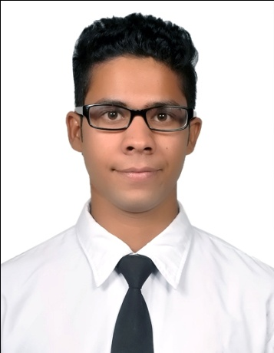
OBJECTIVE
Looking for an ambitious career, where in I can fully use my skills and potential to achieve the corporate objectives and at the fulfilling my career ambition of reaching higher goals and achievements. When will be great recognition.
ACADEMIC QUALIFICATION
- 10th passed from P.S.E.B. with 70%
- 10+2 passed from P.S.E.B. with 68%
- Bachelor of Tourism and Hotel Management from G.N.D.U. with 60% marks

EXPERIENCE
- 3 month experience .(ITC Fortune Park Klassik Hotel in Ludhiana)
- 6 month experience in housekeeping department in (Ramada encore Hotel in Jalandhar)

STRENGTHS
- Hard working
- Patience
- Self confidence

DECLARATIONS

I here by declare that at the information given above is true and correct to best of my knowledge and belief.

