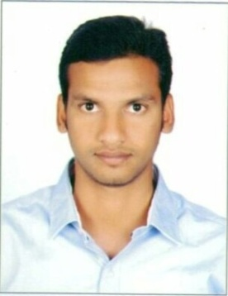
RAJKUMAR
RAJKUMAR.368114@2freemail.com

CAREER-MOTIVE________________________________________________________

I will ready to do whatever role it might be I will face that confidently and very challenging and I try to satisfy or full-fill that role.

EDUCATIONAL QUALIFICATION

B.TECH (INFORMATION TECHNOLOGY) 2008—2012
Jawaharlal Nehru Technological University Hyderabad, Telangana , INDIA
INTERMEDIATE 2006 —2008
Board of Intermediate Education of A.P, INDIA
S.S.C 2005 —2006
Board of Secondary Education of A.P, INDIA

INTERESTING -POINTS

- Anxiety to-words on learning new things.
- Interest on handling difficult situations.
- Interest on more challenging tasks.
- More confident oriented life and work.
- Interest on learning from failure’s.

SKILLS

- IT knowledge: SQL Server DBA (Backup, restore, high availability, etc…)
- Computer knowledge: MS-office (Excel, power point, etc...)
- Marketing knowledge: Research-methodology, SPSS (basic knowledge)

B.TECH PROJECTS

Project name: dangerous gasses detection by using wireless Robot in mining areas

Technology: RF-TECHNOLOGY, SENSORS.

DESCRIPTION: To protect the life mining worker's we use wireless robot. In that we fixed the sensors those sensors are detecting the dangerous gases and fire and smoke also then give the alert for sake we are using one buzzer.

ROLES AND RESPONSIBILITES

We are conducting samples from approximately “1200” people .we approach those through questions (objective type). We are using “E-mail” and social networks like Facebook” for collect the answers from people and we prepare those answers or “samples” on Excel-sheet we prepare and calculate “co-variance & regression, Annova” with the help of Excel and “IBM-Spss”. Finally based on those responses we analyze the smart phone users .We showed in graphical representation also. And also measured the satisfaction levels.

I hear by declare that the information provided above are true and correct to the best of my knowledge.

