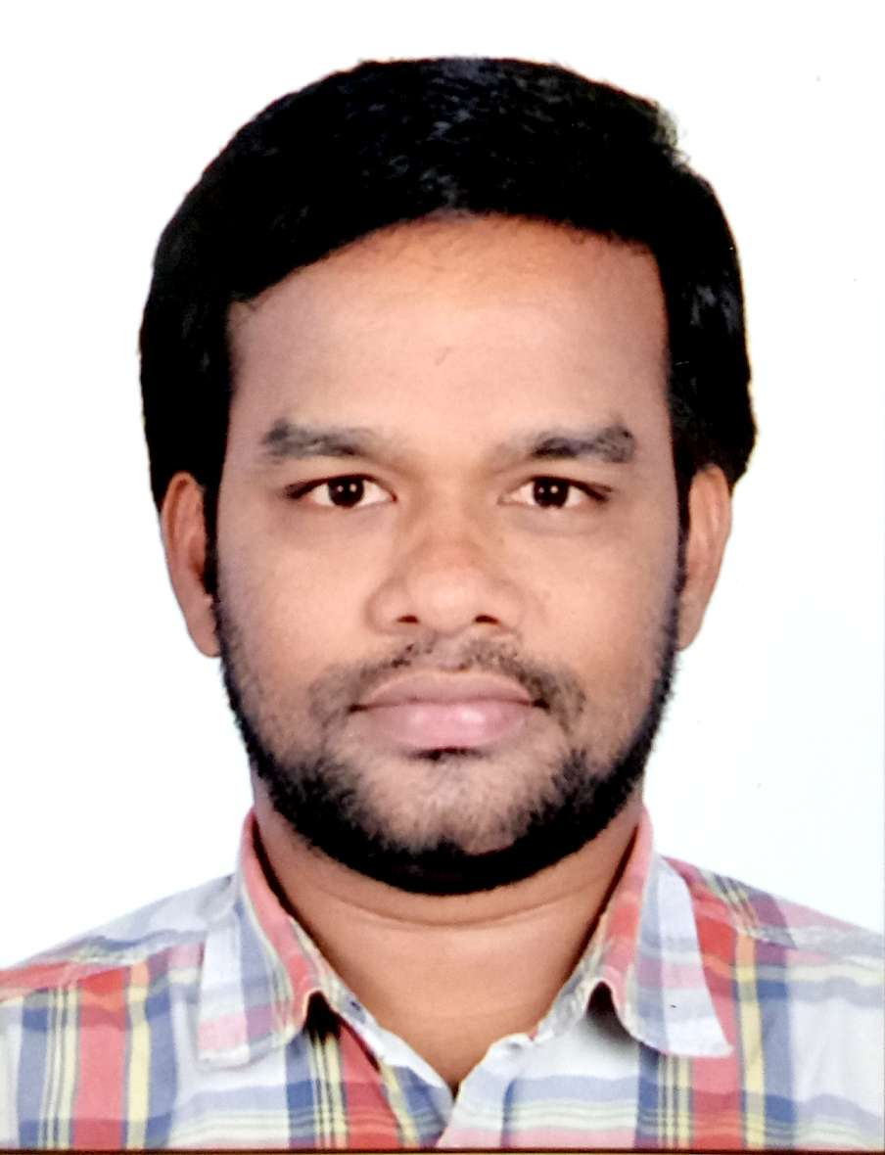
MEDISHETTI
MEDISHETTI.368126@2freemail.com

Objective:

To utilize my potential and knowledge up to full extent for the growth of my organization to thrive with the Growth of my organization to take new challenges and enhance productivity by sincere and with full devotion and enthusiasm.
An outgoing Personality, good interpersonal skills and ability to work in a multi-national team environment with confidence and minimal supervision, comfortable working in a fast paced environment and able to build and maintain good relationship with work colleagues and customer through a genuine desire to understand their needs and support them.
Currently looking for a suitable position that offers variety and the opportunity to develop both personally and professionally.

Job Profile & Responsibilities
Company Profile:- Reliance Fresh kothapet, Hyderabad
Reliance Fresh is the convenience store format which forms part of the retail business of Reliance Industries of India which is headed by Mukesh Ambani. Reliance plans to invest in excess of ₹250 billion in the next 4 years in their retail division. The company already has 1691 Reliance Fresh outlets across the country. These stores sell fresh fruits and vegetables, staples, groceries, fresh juice, bars and dairy products.

Job Profile: Sales Executive, Hyderabad. Duration: March 2014 – September 2016 job responsibilities:
- Provide customer service and assist customers.
- Measuring KPI’s, Footfall, Basket value, Atv’s.
- Maintain hygiene and cleanliness in-store as well as around the fuel pumps.
- Manage and organize stock, prepare stock reports for ordering new stocks.
- Manage Store display and presentation.
- Process bills via cash & EFTPOS operate a computerized console machine.
- Preparing monthly purchase and sales reports.

ACHIEVEMENTS –
- Performed for various national level services schemes (independence day, blood donation camp and others.

EDUCATIONAL QUALIFICATION
- Passed higher secondary level examination from prathibha jr collage.
- B.A from DVM degree college.

COMPUTER SKILLS
- Operating Systems: MS Dos, windows 7 and 8.
- Software: MS Office includes MS Word, MS Excel, MS PowerPoint, MS Outlook.

SKILLS AND STRENGTHS

- Well-organized and highly efficient working in a multitasking Environment.
- Experienced and knowledgeable in use of customer service and sales techniques.
- Confident, dedicated and result oriented person with clear vision towards completing every task in a timely and effective manner.
- Constantly able to work under pressure and meet organizational goals.
- Willing to accept newer challenges and have the ability to look beyond mere targets
Towards organization development.
- Stands for the cause and Interest of the organization.
- Enormous knowledge of precious and semi precious stones.

Interests
I love listening to music of all genres, singing, I like playing outdoor sports and spend a fair amount of my leisure time enthusiastically, visiting social networking sites and watching movies, travelling, making new friends.

Personal Statement
I am ambitious and hard-working, have integrity and am highly motivated. I work well as part of team but am equally comfortable working independently. I strive to do my best at all times. I enjoy developing my skills to keep up with ever changing service industry.

PERSONAL DETAILS
Nationality: Indian
Marital Status : Single
Sex: :Male
Languages: English, Hindi, Telugu.
Driving License: Indian
Visa Status : Visit visa (July 05)(Grace Period)

