RESUME

Dr. SEEMA
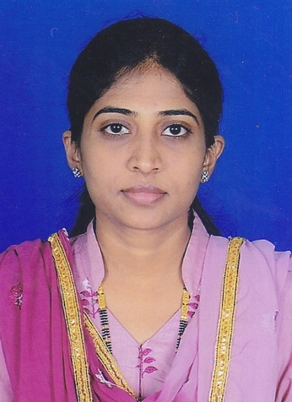
SEEMA.368152@2freemail.com

OBJECTIVE

To utilize my experience to provide quality dentistry in an environment that provides challenges, promotes diversity and stimulates professional growth.

QUALIFICATION

B.D.S {Bachelors of Dental Science}

WORK EXPERIENCE

- JYOTHI DENTAL CLINIC Davangere - India
Designation: Dental surgeon
Period: October 2009 to till date

Responsibilities and Experience

- Examine, diagnose and advise appropriate necessary investigations procedures to define nature of condition utilizing digital radiography and other diagnostic procedure.
- Formulate the plan of treatment for patients.
- Provide excellent chair side communication to enhance the patient experience to build good rapport with patients and sub-ordinates.
- Advice educates and instructs patients regarding preventive dental care, the causes and the treatment of dental problems.
- Scaling root planning and other periodontal needs.
- Provide preventive services of fluoride and sealants.
- Rotary endodontic treatments of posterior and anterior teeth.
- Extractions and minor oral surgical procedures.
- Replacement of missing teeth and other oral ailments with artificial teeth to improve chewing, speech and appearance.
- Treat exposure of pulp by pulp capping or RCT or pulpectomy according to the conditions
- Design make and fit prosthodontics appliances like space maintainer’s crowns bridges or dentures or write fabrication instructions for dental technicians.
- Bleach clean or polish tooth structures to restore to natural colors.
- Treatment of stains and calculus by oral prophylaxis.
- Refer patients to specialists and to relevant patient care components as appropriate.

WORK EXPERIENCE

- COLLEGE OF DENTAL SCIENCE Davangere - India
Designation: Junior Dental Surgeon

Period: May 2008 to September 2009

Responsibilities and Experience

- Examine, diagnose and advise appropriate necessary investigations procedures to define nature of condition utilizing digital radiography and other diagnostic procedure.
- Formulate the plan of treatment for patients.
- Provide excellent chair side communication to enhance the patient experience to build good rapport with patients and sub-ordinates.
- Advice educates and instructs patients regarding preventive dental care, the causes and the treatment of dental problems.
- Scaling root planning and other periodontal needs.
- Provide preventive services of fluoride and sealants.
- Rotary endodontic treatments of posterior and anterior teeth.
- Extractions and minor oral surgical procedures.
- Replacement of missing teeth and other oral ailments with artificial teeth to improve chewing, speech and appearance.
- Treat exposure of pulp by pulp capping or RCT or pulpectomy according to the conditions
- Design make and fit prosthodontics appliances like space maintainer’s crowns bridges or dentures or write fabrication instructions for dental technicians.
- Bleach clean or polish tooth structures to restore to natural colors.
- Treatment of stains and calculus by oral prophylaxis.
- Refer patients to specialists and to relevant patient care components as appropriate.

PERSONAL PERFORMA

DATE OF BIRTH : 10/06/1984
NATIONALITY : INDIAN
MARITIAL STATUS : MARRIED

EDUCATIONAL QUALIFICATIONS

Academic

- 12TH – 2002 KARNATAKA EDUCATION BOARD
- B.D.S – 2007 COLLEGE OF DENTAL SCIENCE RAJIV GANDHI UNIVERSITY

Technical

Computer skills - Working knowledge of Microsoft Office, XP environment

LANGUAGES KNOWN : English, Hindi, Urdu and Kannada.

