Abdul.368199@2freemail.com
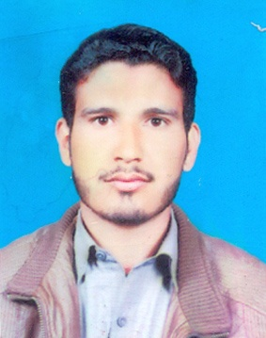 |  | Name |  | Abdul
 |  | Degree |  | DAE-Civil
 |  | Nationality |  | Pakistani
 |  | Date of Birth |  | September 24, 1994
 |  | Gender |  | Male
Career Objective
Seeking a challenging career with a progressive organization that provides an opportunity to capitalize my skills & abilities in field of Civil Engineering.

My Skills Summary

Computer Operater and Concepts.
MS office,inpage.
Internet Browsing & Email.
Camtasia Studio, Filmora Wondershare
Quantity&Quality astimation, Project management skills.
Good communication and presentetion skills
Adobe Photoshop, Web Designing, Fl Studio 12, Adobe Illustrator

Education
Dgree | Insitute/Board | Marks | Passing Year
Metric  (Science) | Mirpur Ajk Board | 626/1050  59% 2nd Division | 2009
F.S.C  (Pre Engineering) | Mirpur Ajk Board | 479/1100  45% 3rd Division | 2011
D.A.E  (Civil Engineering) | KPK Board of Techincal Education | 2448/3350  74% 1st Division | 2014

Experiance
Site Supervisor
Xinjiang Beixin Road & Bridge Construction Co., Ltd
Dec 2014 to June 2016
Total length of Bridge 3.00 Km & Approach Road 1.85Km including, 03 no of Bridges. This is a Mega Project where 803 no of Piles, 67 no of Piers, Height 15 to 28 meter, Pre-stress girder Length 45.80 Meter & Pre-stress Deck Slab The Key responsibilities are checking shop drawing, Bar bending Schedules, Variation orders etc.

Reference
Available On Demond

