 | Curriculum Vitae
Name | IRFAN
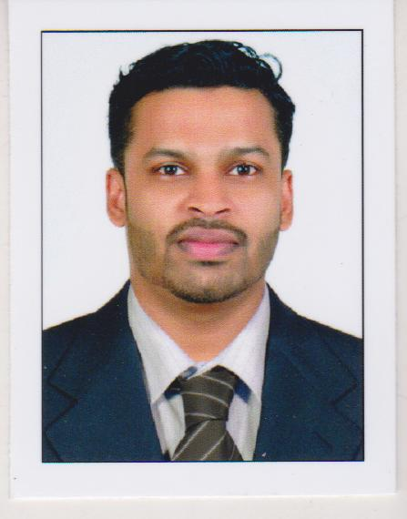 | Irfan.368239@2freemail.com

CAREER OBJECTIVES

To work in an organization whereby my acquired skills, training and work experience can be used in full capacity to fulfill the objectives of the organization while achieving personal and professional growth.
PERSONAL SUMMARY

- A motivated pharmacist with a real passion for health care
- Experienced in maintaining administrative records such as pharmacy files / patient profiles and in providing excellent customer care by accurately dispensing prescribed medications.
- Able to advice patients on medication branch, medication storage medical equipment and health care supplies
EDUCATIONAL QUALIFICATION

- S S L C
- PLUS TWO
- Bachelor of pharmacy

QUALIFYING EXAMINATION PASSED

- MOH PHARMACIST PHARMACY EXAM
COMMUNICATION DETAILS

- Read English, , Malayalam,Hindi,Arabic
- Speak English, Malayalam , Hindi
- Write English, , Malayalam, Hindi,Arabic

WORK EXPERIENCE

- 2 Year And one month hospital experience in EDAPPAL HOSPITAL PRIVATE LIMITED Kerala, India
- 9 months experience in KARUNYA PHARMA Ponnani,kerala,india

JOB DESCRIPTION

  - Accurately dispensing drugs to patient according to a doctor’s prescription
  - Checking prescription for errors and making sure they are appropriate for patients
  - Instruction patients on how to use medication, possible side effect and storage
  - Contacting and working closely with other health care professionals
  - Answering questions from patients and staff about medicine
  - Ensuring the accuracy of all prescription , products and services supplied
  - Managing and resolving complaints.
  - Talking to regular patient to see how their treatment is going
  - Able to trains and supervise pharmacy assistants
  - Communicating with customers sympathetically and supportively
  - Giving private consultation when required
  - Maintaining pharmaceutical stock , creating inventories and ordering more drugs.

PASSPORT DETAILS

- Issued date : 11/08/2011
- Expiry date : 10/08/2021
- Place of issue : Malappuram

PERSONAL SKILLS

- Good team player
- Friendly & polite
- Professional attitude

PERSONAL DETAILS

Sex : Male
Date of Birth : 02/02/1991
Nationality : Indian
Religion : Muslim
Marital Status : Single

DECLARATION

I hereby declare that the above details are correct and true to the best of my knowledge and belief.

Place: sharjah IRFAN
Date:

