RESUME
SOUMYA SOUMYA.368283@2freemail.com

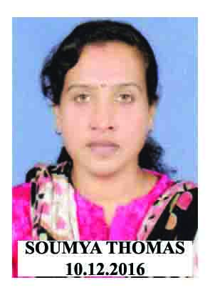  Date of Birth:  4th February1982  Gender: Female  Marital Status: Married  Religion : Christian  Nationality: Indian  Languages Known:  English, Hindi, Tamil, Malayalam.  Hobbies:  Badminton, Traveling, Watching TV,  Reading & Writing | Objective:  To join To join an institute where I can enhance my knowledge & skill where I meet new challenges and give my best to prove my abilities and achieve the goals of the institution Efficiently and effectively. I enjoy working in multicultural environment and I am quite Comfortable in working with different peoples and organization.  Education:  Passed B.com (Co- Operation)  Technical Qualification.  Passed PGDCA (ECIT) and Graphic Designing  JOB PROFILE  Company : NAJATH SUPER SPECALITY HOSPITAL  & College of Nursing  Period : 15th Nov 2014 to till now  Designation : Patient Care Co-ordinator(Counseling)&  Physician’ Assistant  Responsibilities: Developing and coordinating patient care programs. Managing and preparing public relations information. Managing human resources. Handling patient case management. Managing patient care & Account maintain in College of Nursing  Company : CARMEL HOSPITAL &COLLEGE OF  NURSING  Period : 24th April 2011 to 26th Sep 2014  Designation : Office Administrator and Principal’s Assistant  Responsibilities: To plan, organizes, and administers the activities of the department, office, or division efficiently. To keep informed of new developments relating to my function and to maintain a creative and experimental attitude toward change, in order to continuously improve the operation of my area of responsibility.  To provide information and reports to the board at the request of the Principal.  Company : JEMI GROUP OF COMPANY, CHENNAI  Period :14th July 2006 to 20th Nov 2010  Designation : Office Administrator  Project :Movie Distribution  Responsibilities: Maintaining the office files. They must file, label, organize and respond to requests for files from their supervisors or other departments. Maintain general office files including client, accounting and contract files.  Communicating with clients, outside vendors and staff members on behalf of their employer. They greet customers, answer the phone, take messages and set up meetings. Training and supervising other office clerks or receptionists working within their department.  Total Experience: 11 years 1 Month

COMPUTER SKILL

- MS Office
- Windows Xp , Windows 7 & 8
- Graphic Designing

I request you to consider my Qualification & Experience as per your requirements. I have deeply interest.

