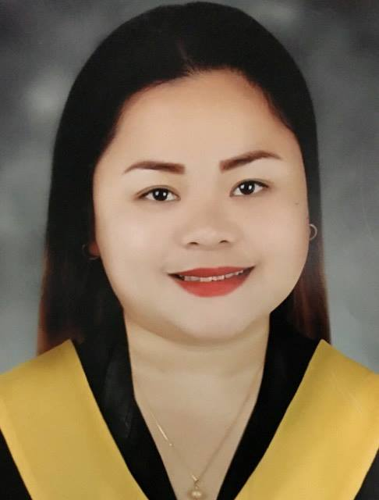
Ritchie
Ritchie.368322@2freemail.com

CAREER OBJECTIVE:

To work in an intellectually stimulating environment, to acquire an entry level position requiring innovative, challenging employment that will utilize my education and professional skills by opening myself to more learning in different fields and share the same to others with competence and faithful service that will utilize my education and professional skills as Individual.

Skills & Abilities:

- Highly motivated and skilled Operations Team Leader who delivers excellence in consistently meeting client standards and even exceeding them.
- Exceptional ability to work under pressure, offering a concrete leader experience complimented by a proven ability to rally performance.
- Strong interpersonal and communication skills.
- I can work with minimal supervision and highly trainable.

PROFESSIONAL HISTORY:

HEALTH WORKER
STAFF ENCODER
Barangay Bago Gallera February 3, 2014 – December 31, 2016
Davao Del Sur Philippines

Duties and Responsibilities

- Provide assistance and support to physicians, dentists, nutritionists, public health nurses, and midwives.
- Render Primary care services in the community.
- Provide services for barangay (neighborhoods) in areas such as maternal, newborn and child health.
- Act as health educators, community organizers, and primary health care providers in their local communities

OFFICE CLERK (Friday and Saturday duty)
ONCALL WAITRESS

SoundBox Party in a Bar March 6,2014-December 31,2016
Legazpi street,Davao del sur,philippines

Duties and Responsibilities

- Communicate with customers, employees, and other individuals to answer questions, disseminate or explain information, take orders and address complaints.
- Answer telephones, direct calls and take messages.
- Compile, copy, sort, and file records of office activities, business transactions, and other activities.
- Complete and mail bills, contracts, policies, invoices, or checks.
- Operate office machines, such as photocopiers and scanners, facsimile machines, voice mail systems and personal computers.
- Compute, record, and proofread data and other information, such as records or reports.
- Maintain and update filing, inventory, mailing, and database systems, either manually or using a computer.
- Open, sort and route incoming mail, answer correspondence, and prepare outgoing mail.

DENTAL AIDE ASSISTANT
RECEPTIONIST
Saavedra Dental Clinic July 13, 2009 – December 31, 2013
Toril, Davao Del Sur Philippines

Duties and Responsibilities

- Welcoming patient/customers in the dental office.
- Prepares treatment room for patient by following prescribed procedures and protocols
- Preparing customers for treatments or checkups ensuring their comfort.
- Selecting and setting up instruments, equipment and material needed.
- Provides information to patients and employees by answering questions and requests.
- Maintain accurate patient records and assist with payment procedures
- Carry out Doctors orders accordingly.
.

AWARDS & SERVICE ELEGIBILITY:

- 2nd Placer Computer keyboard competition (March 1999)
- 2nd Honor of Health Care Services NC II (May 2009)
- Peer Counselor, San Pedro College

EDUCATION:
Tertiary Health Care Services NC II
San Pedro College
Davao, Philippines
Year graduated: 2008- 2009

Bachelor of Science in Information Technology
San Pedro College
Davao, Philippines
Year: 2007-2008

Bachelor of Science in Nursing
Davao Doctor’s College
Davao, Philippines
Year: 2003-2005

PERSONAL INFORMATION
Age: 31 years old
Date of Birth: January 07, 1986
Religion: Catholic
Nationality: Filipino
Languages: Tagalog and English

Character Reference is available upon request.

I hereby certify that all information written above is true and correct to the best of my knowledge.

