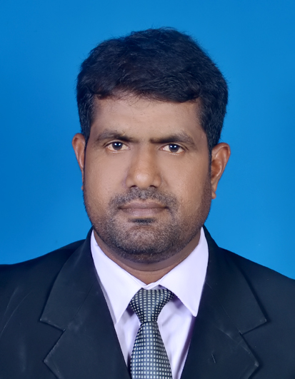
Abdul.368396@2freemail.com

Objective :- To obtain a respectable position in anyarea of Agriculture field and apply my knowledgeto meet as well as exceed the customer expectation
Personal Statement :-
name :- Abdul
Educational qualification :-
Year Name of institute Course
01.2001-2003 College of agriculture, Diploma in Agriculture
Kundasale
Covered Subject area
01.Horticulture
02.Agriculture biology
03.Agriculture engineering
04.Agriculture Extension and Economics
05.Crop Science
06.Food Science and Technology
Year Name of institute Course
02.2013-2015 Srilanka Institute of Advanced Technological Higher National Diploma in
Education English

Professional Experience
I am a professional, committed and qualified agriculture adviser who hopes on the experience I have gained through my work. I have 13 years of working experience in Agriculture field. I can speak English fluently.

- Field coordinator
Period Institute
2003.01.01-2004.12.13 Centre for human development(NGO)

Responsibilities
- Preparing work plan
- Conducting awareness meeting for farmers on project work
- Providing technical training on establishing sustainable home garden with landscaping technique for food security
- Pest and disease management for crop
- Monthly progress submission and presentation

- Social mobilizer
Period Institute
2004.01.01-2005.03.08 North East Irrigation and Agriculture Project (Semi government)
Responsibilities
- Preparing project work plan
- Livelihood programme
- Supervising home garden and conducting training classes
- Formation of Community based organization and conducting capacity building programme

03.Agriculture Instructor(Agriculture Extension officer)
Period Institute
2005.04.01 – Up to now Department of Agriculture,Srilanka.
- Preparing work plan.
- Ensuring the implementation according to timeframe.
- Home garden development with landscaping method.
- Guidingthe farmers for proper agronomic practices.
- Pest and disease management.
- Conducting mobile crop clinic.
- Establishment of demonstration to introduce new technologies in agriculture.

Trainings participated during working period
Topic Period Institution
- Social mobilization 2003 CFHD
- Animal husbandry 2003
- Compost making 2004 Action Cotre La faim
- Conflict transformation
- Integrated Income and food security project 2007 Oxfam
- Project proposal writing DOA
- Skill through English for public servant 12.10.2012-9.11.2012 British council,giz
- How to become plant doctor 23-25.04.2014 plantwise-CABI
- Public relationship Sewalanka foundation
- Permanent acrop Clinic 12-14.09.2014 Global plant clinic of CABI
- Pest and diseas management DOA

Other skill
Computer :-
Ability to work MS Word,Excel,Powerpoint,Photoshop

I hereby declare that the particulars furnished by me in the CV are true and accurate to the best of my knowledge

……………………………
Signature

