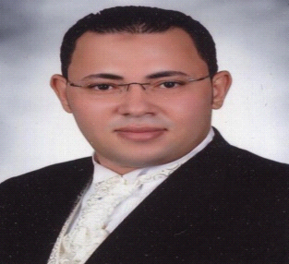 | Marey  Dubai UAE  Marey.368432@2freemail.com

PROFILE  EDUCATION  WORK SKILLS  LANGUAGE SKILLS  WORK EXPERIENCE  DRIVING LICENSE  OTHER SKILLS  PERSONAL DETAILS  INTEREST | Highly qualified, matured, professional motivator possessing extensive experience in various aspects of operations standards with an exceptional record of over 10 years as a shift supervisor , assistant manager,Restaurant general manager in Kuwait Food Company (Americana), UAE. Expertise in Food & Beverage, Operations and Customer Service. Responsible & Reliable, Trust Worthy, Competitive with excellent perks.  Bachelor of Agricultural Sciences – Banha University- Egypt (2004)  Public Speaking –Professional image- Providing a superior customer service- Active listening – Interacting with customers (Kuwait food company - Americana) .  Customer complain and service recovery - Cost Control- call centre agent (El Tawheed we El Noor)Egypt .  How to lead a shift - Customer Mania - Customer Mania Plus - Fish philosophy – Handling difficult customers (Kuwait food company - Americana) .  Arabic (Mother tongue). English (Very good).  Kuwait Food Co. (AMERICANA) April 2007– Till Now Dubai UAE  Restaurant General Manager Providing customer service and knowledge in overseeing crew members and making sure all daily assignments are completed in a timely and efficient manner.  El Tawheed we El Noor co.June 2006–April 2007 Egypt .  Egypt foods Company from; 2004 till 2006 customer service & sales man  Duties & responsibilities:  Meet the customer and explain to him what at are advantages.  Marketing the company services.  Answer all customer questions about our product.  Check the customer buying availability, and confines him to buy.  Explain the contract condition to customer, till customer signature.  Reporting about customer to sales manager in next day briefing.  Light vehicle – Dubai No: 1266398 Issue date: 02\06\2008 Expiry date: 02\06\2018  Exceptional in customer service (voice), public speaking and brand-presentation.  Excellent energy-level, people & time management, resourcefulness, negotiation, teamwork and ethics.  Trained for Effective Interpersonal communication, client & partner hospitality, high touch customer service (non-voice), attention to detail & correct body language.  Trained in use of Fire-extinguishers, emergency evacuation procedures of buildings and first aid.  Able to adapt easily to people from various nationalities and work under pressure.  Computer literate with MS excel, word, PowerPoint and ability to use e-mail, fax, etc.  Internet (Searching and communication through web).  Date of Birth: 01-08-1982. / Nationality: Egyptian. / Visa Status: Employment. /Present Address : Dubai – UAE. / Home Address  El Gharbya- Egypt. /Marital Status: Married.  If given an opportunity with you I will do my best fulfill all jobs entrusted to me sincerely and honestly

