HAMZA hamza.368433@2freemail.com
Result-oriented professional with a proven record of achievement in conceiving & implementing ideas that create value for organization; targeting senior level assignments in Sales / Retail Business / Customer Servicing with a reputed organization in FMCG / Retail sector
hamzasayed66@yahoo.com+971567567297

Profile Summary

- Dynamic career of over 7 years that reflects rich UAE experience & year-on-year success in Sales, Retail Business Development and Customer Servicing
- Skilled in implementing sales activities to create a positive experience for clients; reaching out to new & unexplored market segments & customer groups using segmentation & penetration strategies for business expansion
- Successfully implemented retail operations to meet changing customer needs that lead to accelerated growth, while developing high performance culture
- Directed cross-functional & cultural teams using interactive & motivational leadership; acknowledged for coaching & mentoring team members to achieve resource wise productivity & optimization
- A forward thinking person with strong communication, analytical & organizational skills; well organized with a track record that demonstrates self-motivation & creativity to achieve corporate & personal goals

Education

- BA (ARTS)from Ain Shams University, Egypt in 2008

IT Skills | Key Skills
- Microsoft Office (2007, 2010 & 2013), Microsoft Windows W7 & W8 and Internet Applications  Soft Skills  Personal Details  Motivational Leader  Change Agent Thinker  Collaborator Planner  Communicator  Date of Birth: 01/10/1986  Address: Abu hail-Dubai  Visa Details: Employment Visa (sponsor /Homes r us)  Nationality: Egyptian  Driving License Details: U.A.E. Driving License .  Languages Known: Arabic, English and Germany | Sales  Retail Business Development  Customer Servicing  Store Operations  Relationship Management  Liaison & Coordination  Process Improvement  Training & Development  Team Management
Career Timeline  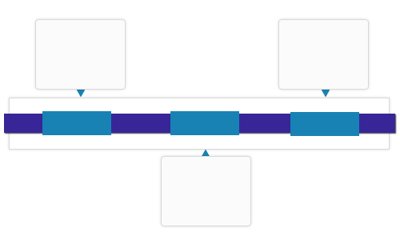  Aug’08-Feb’10  Hyper one, Cairo / Egypt (Hyper Market) as Sales Representative  Jun’11-Jan’16  Carrefour Hyper Market, Majid Al-Futtaim Group, Fujairah, UAE as Supervisor  Since Mar’16  Homes R Us Furniture & Furnishing, Dubai / UAE (Lals Group) as Senior Sales Associate |  | Achievements  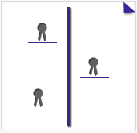  Best Employee of the Month Award in Aug’12 & Apr’13  Appreciated as Best Employee by Store Manager
Work Experience

Since Mar’16: Homes R Us Furniture & Furnishing, Dubai / UAE (Lals Group) as Team leader

Role:
- Charting out sales strategies and enhancing business volume as per profitability norms
- Monitoring, mentoring &motivating sales stuff
- Assuring that all pricing, signage and display are correct all times
- Assisting in all store operational tasks (inventory, cash protection, loss Prevention, overhead and supply costs)
- Liaising with Sales Manager for sales issues &objectives
- Devising & effectuating go-to-market strategy and introducing products to win mutually beneficial deal; pioneering business development to enhance revenues by identifying market opportunities
- Resolving client’s escalations / concerns and addressing their queries (customer advocacy) for a smooth ride for customer’s diverse issues

Highlights:
- Appreciated as Best Employee by Store Manager for sales skills, hard working and best service which given for clients since 2nd week of joining
- Over-exceeded monthly & quarterly target by 3%
- Amplified customer base by 3% through maintaining effective relationships (Motivate sale associate stuff daily, encourage them and overseen them activity time to time)
- Identified target markets and established successful plans to develop them.

Jun’11-Jan’16: Carrefour Hyper Market, Majid Al-Futtaim Group, Fujairah, UAE as Supervisor

Role:
- Created performance improvement plans if an employee performance was not adequate
- Lead customer service operations involving receiving complaints and resolving problems
- Attended monthly sales meeting and reported the same to Department Head

Highlight:
- Bagged Best Employee of the Month Award in Aug’12 & Apr’13

Aug’09-APR’10: Hyper one, Cairo/Egypt (Hyper Market) as Sales Representative

Role:
- Explained about how to use the products requested by customers
- Ensured that the customer display end was attractive
- Placed price tags on items and prepared the inventory / stock
- Developed productive trust relationships with customers

Highlight:
- Elevated section sale contribution from 6.8 to 7.5 % of the whole store sales.

