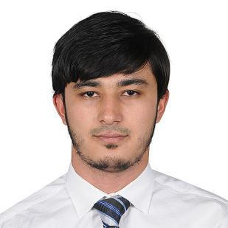
Ibodulloh Ibodulloh.368473@2freemail.com

Professional Profile

Graduated from Islamic University of Madinah specialized in Arabic Language and Islamic Studies, knowing deeply Shariah Law and linguistic methods. I have skill of lecturing and teaching with good research ability.

Furthermore, I have strong administrative and organizational skills, experienced in leadership positions and problem-solving, work effectively both as team member and independently, excellent communication and IT skills, enthusiastic and committed.
Education and Qualifications

E.g. Bachelor Sc Arabic Language ( Islamic University of Madinah), 2016

 | *Arabic rhetoric | * Islamic Jurisprudence
 | * Arabic grammar | * Research methods
E.g. Diploma | Educational preparation ( Islamic University of Madinah), 2016
 | *Teaching Methods |  | * Educational psychology
 | * Education & community development * Foundation curriculum
E.g. Diploma | Linguistic preparation ( Islamic University of Madinah), 2012
E.g. 10 GCSEs | Secondary School # 11 ( Khujand city, Tajikistan), 2009
 | * Mathematics | *Physics | * Persian Language and literature
 | * English language | * Biology | * Russian Language
Trainings & | • The Student Leadership Challenge (Benaa Group of Education, Saudi Arabia), 2016
Courses | • Skills of thinking ( Islamic University of Madinah), 2015
- Strategically Planning skills ( Islamic University of Madinah), 2015

- Networking fundamental ( Islamic University of Madinah), 2015

- Intensive English courses ( The Language House, Kuala Lumpur, Malaysia), 2013

Notice: Now studying in Master degree of Arabic Literature and Rhetoric.
Associated Experience

Dates to and from | JOB TITLE, Company
09.2015 to 02.2016 | Practitioner teacher in middle school of Islamic University of Madinah
Dates to and from | JOB TITLE, Company
09.2015 to 09.2016Receptionist and official translator in Islamic University of Madinah, Saudi Arabia
Dates to and from | JOB TITLE, Company
01.2017 until now | Translator in Diamond Microscope Br. Est. Jeddah, Saudi Arabia
Other Experience
Dates to and from | JOB TITLE
2012 | Since 2012 engaged in self-trading goods between UAE, KSA and Tajikistan countries
Dates to and from | JOB TITLE
03.2015 | Chairman of Tajikistan Pavilion at the Festival of Cultures and Peoples. ( Our Pavilion won 1st
 | place among 60 participation countries and we got a new car as a prize)
 | 1

Dates to and from JOB TITLE

04.2016 Chairman of Tajikistan Pavilion at the Festival of Cultures and Peoples. ( Our Pavilion won 1st

place among 64 participation countries and we got a new car as a prize for the second time)

Dates to and from JOB TITLE

01.2016 to 11.2016 Chairman of Tajik students’ association in Islamic University of Madinah
Key I.T. Skills

➢ | Microsoft Office | ➢ | Microsoft Windows
➢ | Fundamental networking | ➢ | Cool edit pro
➢ | Video montage | ➢ | Islamic Library ( Maktaba al- shamila)
Other / Personal Details

Interests include: Economic, Tourism, Politics, Sport, Entertainment, Cookery.

REFERENCES ARE AVAILABLE ON REQUEST

2

