CURRICULUM VITAE

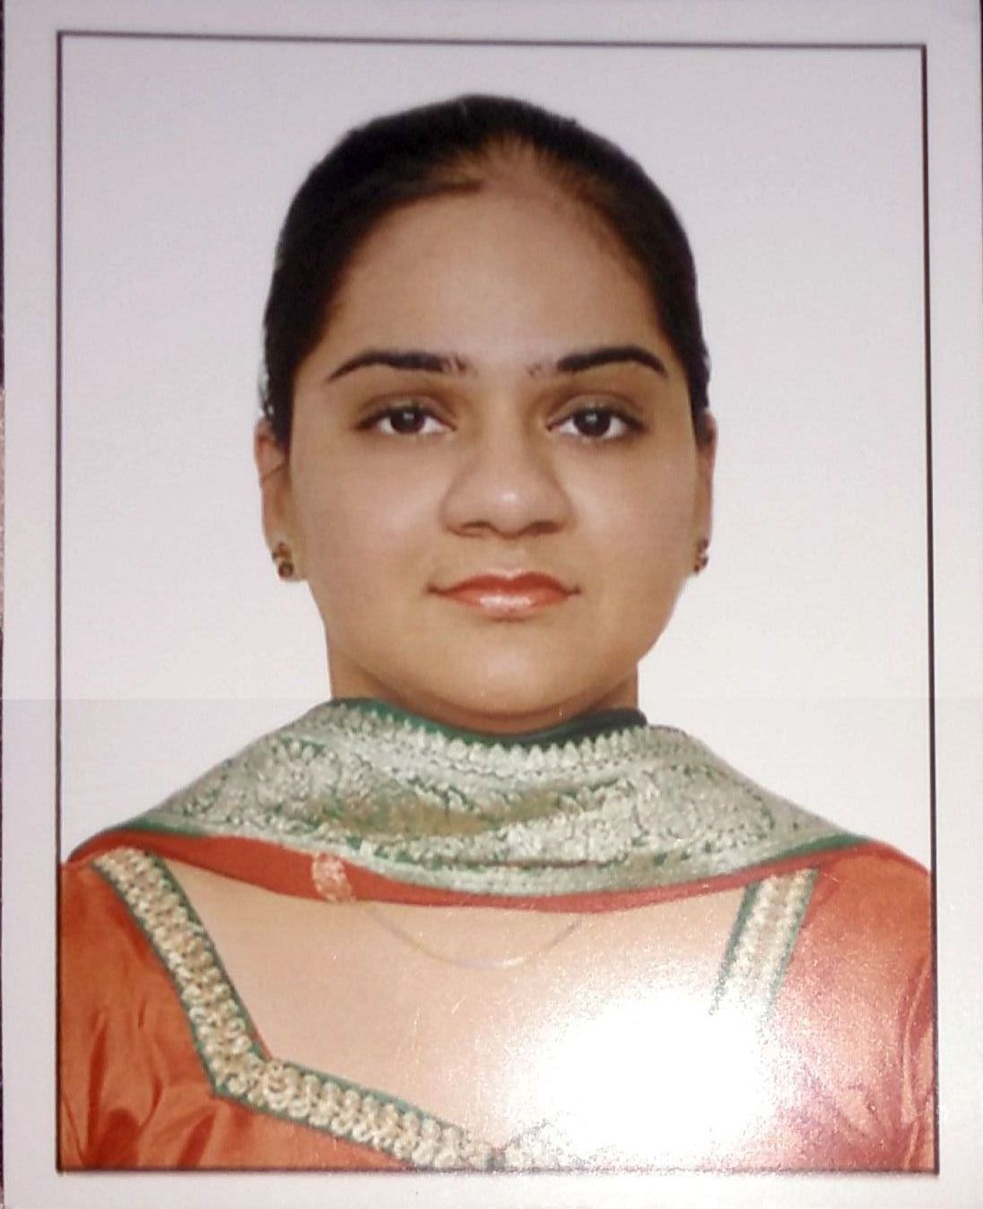

MANMEEN MANMEEN.368477@2freemail.com

CAREER OBJECTIVE
To pursue Teaching profession with zeal to work in new field and accept challenging tasks that will utilize my overall activities, skills, and knowledge for the students age and transfer it to kids effectively by cultivating the special awareness and talent to enable them, integrate smoothly into the society and become better person in life.

WORKING EXPIERENCE- 3 years
- Working as Primary Teacher in Guru Tegh Bahadur Public School, Krishna Market, Lajpat Nagar-I From February 2013 to still working.

PROFESSIONAL QUALIFICATION

Junior Basic Training (JBT)(2010-2012) from MP Board .
- CTET ( SEPTEMBER 2015) from CBSE .
- Pursuing Diploma in special education( H. I) from C. B. S. M college.

EDUCATIONAL QQUALIFICATION

Pursuing M.A (English) from Algappa university

B.Com. Pass(Correspondence) (2009-2012) from Delhi University .
- Higher secondary (CBSE) (2008-2009) from Guru Harkrishan Public school, India gate, New Delhi .
- Senior secondary (CBSE) (2006-2007) from Guru Harkrishan Public school, India gate

COMPUTER SKILLS
- Operating Systems: Windows 9x, 2000, XP,7.
- Other Software’s: MS Office, Paint,Adobe Photoshop, Adobe Acrobat.

CORE COMPETENCIES
- Good problem solving skills,initiative and judgement.
- Logical reasoning
- Ability to handle the pressure and responsibilities.
- Good interpersonal and communication skills.

AREAS OF INTEREST:
- Developing the methodologies for the growth of an organization
- Utilizing the self-made policies to acquire the positive results on the task

OTHER ACHIEVEMENTS

- Participated in group song competition organised by Delhi Schools of Cultural Activities Board and achieved 1st position.
- Received a certificate from NCC for passing the exam held in 2007
- Received a certificate of Social Service From Cancer Aid Societyand a gold medal and cup.
- Received a certificate from Shiamak dance institute for participating in summer funk show.

ADDITIONAL RESPONSIBILITIES HELD IN PRESENT SCHOOL
I have been working in the capacity of :-
- Guiding little ones to enhance their computer skills.
- Organizing Fancy dress and various other co-curricular activities at school.

LANGAUAGE KNOWN: Hindi,English,Punjabi

PERSONAL INTEREST: Travelling, shopping ,Exploring restaurants.

PERSONAL INFORMATION:

Date of Birth : 25th August 1991
Marital Status. : Married
Nationality : Indian
Sex : Female

STRENGTH
I Usually try to follow a very positive attitude and try to do my work with 100% efficiency.
I always set my standards and try to achieve it with 100% results. The best thing in me is to
Follow the discipline at every moment of my life. My parents and friends are my biggest strength.

I hereby declare that the above written particulars are true to best of my knowledge and brief.

