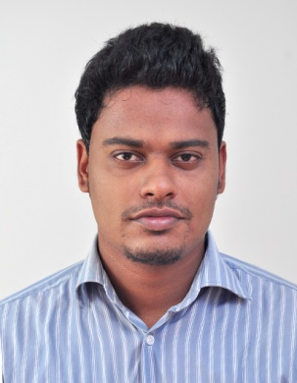

AMBIT
AMBIT.368494@2freemail.com

Obtain a position in a leading Organization where I can maximize my leadership, coordination and communication skills.

Core Competencies

- Brand development.

- Market research and competitive analysis

- Lead generation, lead management and nurturing

- Development and presentation of innovative sales pitches

- Strategic planning and development of improved strategies to expand sales

- Team building and project management

- Client relationship management

- Development of effective proposals and documentation of subsequent business development activities

Employment Details

May’11- Aug’2012 with Sutherland Global Services as Consultant.

Jan’13-Jan’15 with C-Cubed solutions ltd. As Sr. SEO analyst cum Content writer.

Since Feb’15 as a Business Development Executive in Cross Waves International Shipping Services LLC

Key Result Areas

- Providing effective solutions to the customers by listening patiently to their queries.

- Handling customers’ inquiries and sending quotations to them at the earliest.

- Handling customs documentation and doing regular follow ups with clients.

- Developing insightful, thorough recommendations to improve the overall business of the firm.

- Handling office administration as well as interacting and arranging meetings with the clients.

Highlights:

- Adept in customer service and sales coordination and also in pacifying irate customers.

- Excellent communication skills that enable to delve into the details of the customers’ queries and provide easy solutions in short time.

Interpersonal skills:

- Presentation skills and confidence in introducing new ideas and
initiating meetings with clients

- Communication skills that help in maintaining social as well as
professional relationships

- Leadership ability and high motivational skills that help in encouraging team members to work together

- Ability to handle and effectively communicate with different types of customers

- Socializing skills that help in encouraging team members to come up with and express new ideas

Education

- B.Sc (Biotechnology) from M.M.N.S.S. College, Konni, Kerala with 65%
- XII from New Green Fields Public School with 65%
- Xth from New Green Fields Public School with 85%

Personal Details

Date of Birth: 13th July, 1988
Languages Known: English, Hindi, Malayalam
Nationality: Indian
Marital Status: Single

