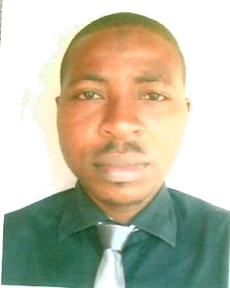LAWAL
Contact:
Lawal.368512@2freemail.com

TEACHER

PROFILES

Personal Statement: I am highly proficient in the area of pedagogy and my experience is there for your peruse. I am more passionate about imparting knowledge on young ones because it gives me joy.
Career Objectives: Seeking a position that will take advantage of my knowledge, while providing me the opportunity to grow, learn and develop and then contribute my own quota towards the success of the organization.

WORK EXPERIENCE
EDUCATION
SKILLS
KEY SKILLS:
• Ability to manage multiple tasks • Good communication skills
• Integrity and Honesty • Good presentation skills
• Good interpersonal relations • Good team work spirit
• A can-do-it spirit • Ability to work under pressure

- Bachelor of Science – Transport and Logistics 2007-2011
Tai Solarin University of Education, Ijagun Ijebu-Ode,
Ogun State, Nigeria
- Command Day Secondary School, Odogbo Ojoo, 1998-2003
Ibadan Oyo State, Nigeria (WASSCE 2003)
- Ad – Deen International School, Challenge, Ibadaan 1990-1995
(Primary School Leaving Certificate)
- Al Aziz Memorial Islamic School, Off Akanfe Street, Olorunsogo 2012-2014
Akanran Road, Ibadan, Oyo State Nigeria
POST HELD: Teacher
SUBJECT TAUGHT: Mathematics, PHE and Business Study

- Takbir International School, Iwo road Ibadan, Oyo State, Nigeria Full Time
POST HELD: Class Teacher/Subject Teacher 2014-2016
SUBJECT TAUGHT: English, Quantitative and Verbal Reasoning
The references are available upon request

- Managing and Coordinating of Student affairs

REFREE

