CURRICULUM VITAE
MANOJ
MANOJ.368545@2freemail.com
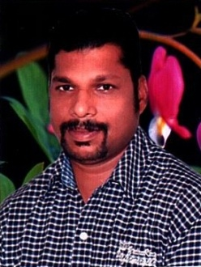

PROFESSIONAL EXPERIENCE
- SARAYA AL MADINA GENERAL TRADING L.L.C. - DUBAI -UAE
Post: Office in Charge / Asst. Manager [ 2009 January To 2017 Feb.]
Duties and Responsibilities
- Office Administration and Office routine work’s
- Managing Co. Staff and Supervising Day to Day jobs
- Filling & Maintaining the Co. Data
- Maintaining Company Staff Data base
- Greets visitors and performs general administrative duties.
- Answer telephone, take messages and answer inquiries
- Perform basic administrative duties
- Admin and HR functions
- Schedule appointments, maintain calendar
- Develop and maintain a filing system
- Make travel arrangements
- Prepare and manage correspondences, reports and documents
- Manage office supplies
- Co-Ordinate with Sales team for smooth running business
- Inquiry for new and existing Customer requirements
- Supporting with Delivery staff to deliver the goods

- BLACK EYES TRADING CO. L.L.C. DUBAI -U.A.E.
Post: Office in Charge [2004 July-2008 November ]
Duties and Responsibilities
- Filling & Maintaining the Co. Data
- Office Administration and Office routine work’s
- Managing Co. Staff and Supervising Day to Day jobs
- Maintaining Company Staff Data base
- PHOENICIA HOTEL – DUBAI – U.A.E
Post : Administrative Assistant in H.R. Dept. [1998 June - 2004 -May]
Duties and Responsibilities
- Maintaining Staff database
- Preparation of Staff Duty Resuming report to the General Manager
- Periodically checking staffs In and Out Time cards and Preparing Overtime
- During the absence of PRO , the following official works will be handled independently
A] Guest Visa submission at Airport and receiving the Hotel Guests
B] Processing of Staff Residence Visas / Labor Cards & Medical Reports
ACADEMIC QUALIFICATIONS
S.S.L.C [Certificate]
H.S.C. [Certificate]
B. A. [ Course not Completed ]
Technical Qualifications
Diploma in Computer Application
Finding information through Internet, sending messages through E- Mail .
Personal Details
Date of Birth : 15th April 1978
Nationality : Indian
Marital Status : Married
Visa Status : Visit Visa
Languages Known : English, Hindi, Malayalam, Tamil & Marathi
Reference available upon request.

