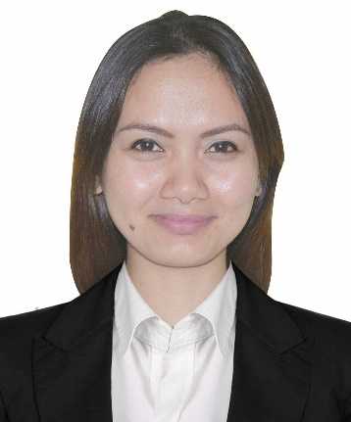
ANALYN
ANALYN.368609@2freemail.com

Career Objective:

Seeking a challenging position in areas of communication and office administration utilizing my in-depth skills to add contribution towards the success of the company.

Core Competencies:
Marketing and Communication skills
Numerical aptitude
Resourcefulness
Problem Solving Abilities
Team Player
Multi-tasking
Analytical skills
Computer skills

Professional Experience:

Sales Executive, Aug 2015- present
ETISALAT, Madinat Zayed Shopping Center branch
Abu Dhabi, UAE

- Sells all products and services that the company is offering.
- Successful background in Customer Engagement
- Possess a competitive desire to meet and exceed sales goals/targets.
- Handle all administrative aspects of the sales including: completing customer request, accepting customer payments and filing the completed orders.
- Maintain strong knowledge of all products, accessories, pricing plans, promotions and service features.
- Maintain knowledge of competitive offers and provide critical market feedback to the Store Supervisor regarding local competition and product/service needs.
- Handle service inquiries from customers.
- Provide efficient, courteous customer service and assist in all aspects of product offerings and services. Educate and engage customers through product demonstrations
- Knowledge of different computer skills.

Process Executive, Dec 2012- Jul 2013
Infosys BPO Ltd., Bonifacio Global City
Taguig, Philippines

- Works in a Business Process Outsourcing industry and provides service to one of the US multinational Telecommunications Corporation.
- Responsible in placing customer order request regarding fixed line and mobile telephony, broadband and internet services.
- Analyzes and inputs data information into the system.
- Process orders in an accurate and timely manner.
- Conducts call to client for further verification of information provided to assure the proper and on-time delivery of service.
- Coordinates with the technical team to resolve issues arising on a particular request.

Data Assistant, Mar 2011- Mar 2012
Accenture Inc., Eastwood Cyber Park
Libis, Quezon City, Philippines

- Works in a Business Process Outsourcing industry servicing one of the insurance companies in the US.
- Analyzes and interprets patient’s data.
- Review and assess claims submitted to ensure if covered for a medical procedure by the insurance company.
- Performs claim adjusting calculations.
- Pend or deny a claim for further review or investigation.
- Coordinates with other department for any unresolved medical data issues.

Education:

Bachelor in Commerce major in Marketing, June 2006- Apr 2010
Batangas State University
Nasugbu, Batangas
Philippines

Internship:

Retail Associate, Sept 2009- Mar 2010
Mini Toons Pte. Ltd
Jurong Point, 1 Jurong West Central
Singapore

