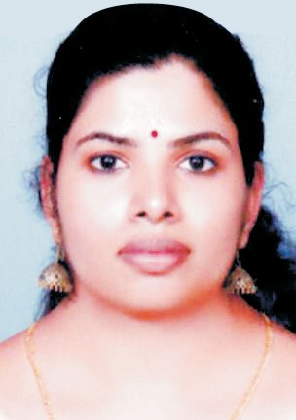................................................
C U R R I C U L U M V I T A E

Layana
C
u
r
r
i
c
u
l
u
m
V
i
t
a
e
........................................................................

Contact details:

layana.368614@2freemail.com

C
U
R
R
I
C
U
L
U
M
V
I
T
A
E
Academic Profile

MSc Applied Psychology ( pursuing, will be completed in 2018) Annamalai University, Directorate of Distance Education
M.A in English Language and Literature
University College, Thiruvananthapuram, Kerala Kerala University (2008-2010)

B.Ed in English
SNGK Teacher Training Institute, Thiruvananthapuram, Kerala Kerala University (2013- 2014)

B.A in English Language and Literature
S.N College, Chempazhanthy, Kerala Kerala University (2005-2008)

HSE(Science with Computer Science)
SNGHSS, Chempazhanthy, Kerala
Directorate of Higher Secondary Education (2002-2004)

SSLC
GHSS Ayirooppara, Thiruvananthapuram, Kerala Board of Senior Secondary Examination

Career History

Muslim Association College of Engineering, Venjaramoodu, APJ Kerala Techinical Univercity ( 15 April 2016 - 15 Apri 2017 )
Assistant Professor in English Duties
Enhance the employability skills of engineering students to match the industry needs.
Help students to develop their communication skills so as to performwell in Group Discussions and Personal Interviews Observe and develop student's linguistic performance, progress, behavior and social development
Encourage students to work on self development and face the world with confidence.

