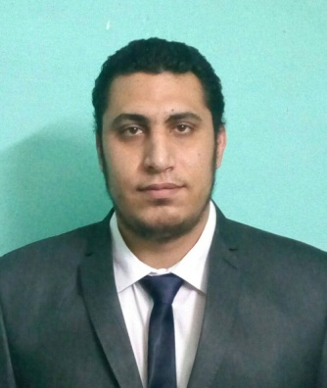
Name: Ahmed
E-mail: ahmed.368663@2freemail.com

Personal summary:-
A motivated pharmacist with a real passion for healthcare and the ability to develop grow business.
Career objectives:-
To pursue a highly rewarding career, seeking for a job in challenging and healthy work environment where I can utilize my skills and knowledge efficiently for organizational growth.

Work Experience:-
1. El-Nahda El-Gedida medical center
Governmental Pharmacist from Apr-2016 to Apr-2017
Al Salam city – Cairo – Egypt
The ministry of Heath assignment, medical center in a small town mostly paper work than patients, but i learned how to multitask paper work besides helping more than one patient at a time.

2. El-Ezaby pharmacies group
Pharmacist from July-2015 to Oct-2016
Cairo- Egypt
Triumph branch, Hurgada 3 branches "Senzo- Dahar – Hurgada airport" and Souq El-Rehab branch
during that time I gained more experiences and took a lot of responsibilities, I learned more about the system and how to deal with problems, I was responsible for training the new comers in most of branches I worked at, I wasn't the higher rank but I was assigned more duties than others and I always had new ideas to make the work more efficient and organized.

3. Seif pharmacies group
Pharmacist from Dec-2014 to May-2015
Sven stars mall – New Cairo - Egypt.
Started working as a pharmacist, 12hours shift, first time chain pharmacies I Learned about insurance companies, imported drugs and how such a big pharmacy operates.

4. Fatma Saber pharmacy
Pharmacist from Jul-2014 to Nov-2014
Bagour – Menofia – Egypt.
Working as pharmacist full time job dealing with day to day pharmacy work, customers, paper work, ordering drug supplies and keeping tracks on pharmacy records.

5. Tahany pharmacy
Student Pharmacist from Jan-2012 to Feb-2012
Shebin El-Kom – Menofia – Egypt.
Working as student pharmacist, learning more about drugs and applying knowledge from college to real pharmacy.

6. Wessam pharmacy
Trainee from Jul-2011 to Sep-2011
Kafr El-Meslha – Shebin El-Kom –Menofia – Egypt.
Training through the summer vacations and getting familiar with drugs and pharmacies system.

Academic Qualifications
Eligibility letter for DHA License Mar 2017
Bachelor of pharmacy 69 %
Faculty of pharmacy Cairo University class 2014
El-Kasr El-Aainy – Giza – Egypt.
High school degree 96.4 %
Golden techs high school 2009
Shebin ElKom–Menofia–Egypt.
Key skills and competencies:-
Able to provide quality face to face customer interaction.
Creative, problem solver, responsible and always have new ideas.
Can work under pressure and finish before deadlines.
Areas of expertise:-
Dispensing medication, Commercial awareness, Administration, Health promotion, Customer service and Management of medicines.
IT Background:-
Well versed with Microsoft Office Package, Internet Applications, and ICDL
Languages:-
Arabic: Mother Tongue.
English: Excellent.
References:- Available on request.
Personal information and visa status
Male, 25, Single. Tourist visa till Aug-2017.
ahmed.368663@2freemail.com

