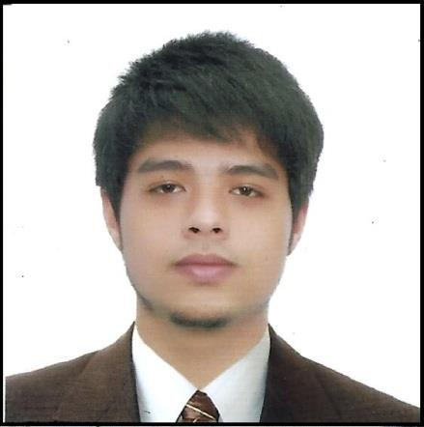
Johannes

BS Computer Engineering, Technological Institute of the Philippine (TIP), Quezon City, 2008-2014

Email: Johannes.368711@2freemail.com

OBJECTIVE

Interested in obtaining a position where in I can challenge myself in a new environment that focuses on the applications of technology to enterprise knowledge management, distributed computing, e-Business, and system engineering and design.

ON-THE-JOB TRAINING/ PRACTICUM/ WORKING EXPERIENCE/S

• I C T O f f i c e r | M o n o c r e t e C o n s t r u c t i o n P h i l s . , I n c . T a g u i g C i t y

  - July 2014 – May 2016
    - Supervising Technical support team
    - Organized and installed new network infrastructure for the company

    - Performed maintenance of computers and peripheral equipment, identifying problems and providing appropriate solutions

    - Setup and maintain digital imaging devices and telephones.
    - Server administrator – Thin client, Rackstation(file server), MYOB server
    - Installation and implementation for CCTV and RFID devices
    - Implementation and Configuration for handheld radio and mobile radio
    - Installation and maintain of Security Devices(Anti-Virus)
    - Document control, IT Stocks monitoring

- Technical support – trainee | ADTEL Inc. Kalayaan Ave. Quezon City
  - February 2014 – March 2014
    - Pc troubleshooting
    - Network Configuration(router, switches)
    - Monitoring On-site projects
    - Installing CCTV cameras, Wi-Fi modems etc.

KNOWLEDGE, SKILLS AND ATTITUDE

- Creating a best solution for problems related to engineering.

- Knowledgeable in terms of networking fields and can perform a quality of service in trouble shooting.

- Provide a good quality of service to the clients

- Knowledgeable for the servers of Proxy, Email, Sap, Active directory, MS servers and SAP.
- Documentation ( HIRADC, CA&PA, Monitoring, Inventory)
- Knowledgeable in Web developing and designing
- Knowledgeable in Java programming, Mysql database
- Installations of ELV systems such as CCTV, access control, etc and Network connections

- Knowledgeable in LAN/WAN, VLAN, DHCP, DNS, Firewall, TCP/IP connections and VPN connections

SEMINAR/S AND TRAINING/S ATTENDED

- Cisco Certified Network Associate (CCNA) .June 19, 2013 Experts Academy, Makati City

ID NO: CSCO12379117

- Certification in IPv6 newbie, 2013 Experts Academy, Quezon City

- Network security Seminar, September 2013 Experts Academy, Quezon City

- Data Centre Fundamentals Seminar, September 2013 Experts Academy, Quezon City

- Network Security Primer Seminar, September 2013 Experts Academy, Quezon City

EXTRA AND CO-CURRICULAR ENGAGEMENTS AND VOLUNTEER WORKS

- Integrated Computer Organization (ICON) – Member Technological Institute of the Philippines, 2010-2014

- Institute of Computer Engineering of the Philippines(ICpEP.se)- Member Technological Institute of the Philippines, 2010-2014

OTHER SKILLS

- Efficient in Microsoft Word, Microsoft Excel and Microsoft PowerPoint
- Average in communicating skills (English)
- Ability to Work in a Team Structure
- Responsible in any work
- Fast Learner
- Risk Management
- Understanding IT Legal and Ethical Issues

 | Personal Information
 | Date of Birth | : | January 31, 1992
 | Gender | : | Male
 | Marital Status | : | Single
 | Religion | : | Roman Catholic
 | Nationality | : | Filipino
 | Visa Valid until | : | May 23, 2017
 | REFERENCE

Provided upon request

I hereby affirm that the above information is true and correct with the best of my ability.

Johannes

Application Signature

