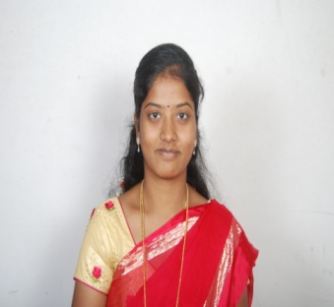
NAME: JULIE
Email ID: julie.368726@2freemial.com

CAREER OBJECTIVE: To be a part of the career oriented industry where my growth and expansion will be along with the organization.

WORK EXPERIENCE:
Currently working as an Asst.Teacher at St. Xavier High School, Goregaon (East) from June 2016 to April 2017
EDUCATIONAL QUALIFICATION
COURSE | INSTITUITION | UNIVERSITY | PERCENTAGE OBTAINED | Year
D.T.Ed | St. John’s Teacher Training School. | Mumbai-  University | 1st year- 70.8%  2nd year- 72.55% | June-2015
B.com(BBI) | Vivek college of Commerce | Mumbai-  University | 69% | April-2013
HSC | St. Annes Jr.College | Maharashtra Board | 64% | Feb-2010
SSC | Carmel of St. Joseph School | Maharashtra Board | 57% | Mar-2008

COMPUTER KNOWLEDGE:
- Tally ERP 9
- Basic Computer Knowledge

PERSONAL DETAILS
DATE OF BIRTH : 09thFebruary 1992.
SEX : Female
NATIONALITY : Indian
MARITAL STATUS : Married
INTEREST : Crafts and Cooking
BLOOD GROUP : O+
RELIGION : Roman Catholic.
LANGUAGES KNOWN : English, Hindi,
Marathi and Tamil
I hereby declare that the information provided above is true to the best of my knowledge and beliefs. I understand that in the event of any information being found false or incorrect my appointment is liable to be cancelled/terminated.
PLACE: Mumbai.
JULIE

