Personal Profile

Eager to meet challenges Creative Hard-worker Highly energetic Innovative thinker Proactive Reliable and Loyal Result oriented Team player

Work under pressure

Computer Skills

Amadeus

Galileo

Abacus

MS Windows

MS Office (Word, Excel,

PowerPoint)

Internet

Languages

English.

Malayalam.

Interest

Dancing, Traveling, Music
CURRICULAM VITAE.
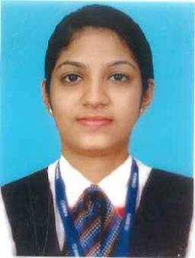

Hridya
Hridya.368732@2freemail.com

To become a part of result oriented and successful team involved in innovating and implementing new ideas in tune with latest aviation development otherwise with revolutionary changes in the high sky’s and further pursue an assignment with a concrete vision in the field of aviation industry.

TECHNICAL QUALIFICATION.

M.Degree | : | MBA - Human Resource
Degree | : | BA English Literature.
Diploma | : | Airport Operations Management
Diploma | : | IATA-UFTAA Consultant
Performance | : | Distinction.

EDUCATION

Higher secondary school certificate, VPMSNDP Trichur. Kerala. – Distinction.

SSLC. VPMSNDP Trichur. Kerala - Distinction.

PROFESSIONAL EXPERIENCE

One year experience at Cochin International airport - India as airport staff of Etihad Airways

AREA OF EXPERTISE

Assists passengers to provide a safe & secure travelling

Verification of ticket , passport & visa to ensure a legal and safe travelling

Assist in the development and coordination of aviation policies and procedures to correct unsafe conditions and ensure aviation safety.

Assists with revisions and updates of airport rules and regulations and minimum standards.

Ensure an operationally safe airport that is in compliance with latest international & National aviation regulations

Ensure to adopt safe work practice and apply all the elements of quality control.

Monitor the arrival, parking and departure of all aircraft.

CURRICULAM VITAE.

Ensure a safe & secure baggage handling. Dealing with client & Authorised departments

- COURSE ATTENDED:

DGR (Dangerous Goods Regulation) Ramp Safety

PERSONAL INFORMATION:

Date of birth : 20 December1992 Trichur. India

Marital Status : Married.

Visa Status : Residence visa.

Reference : Available upon request

I hereby declare the above information is True to my knowledge and belief.

Hridya

